The Assessment Management System Handbook for Assessment Leaders

Version 1.7
Updated February 28, 2022

Table of Contents
AMS Quick Start 4
Logging In and Selecting a Program 4
Entering/Editing PLOs 4
Designating PLOs to Assess 4
Entering Assessment Methods 4
Entering Results 4
Submitting 4
Introduction to the AMS 5
About the AMS 5
What is the AMS? 5
Roles within the AMS 5
Need Assistance? 6
About This Manual 6
How This Manual Works 6
Important Information Before You Begin 7
Getting Started 8
Log In/Access AMS Nuventive Improve 8
Navigating the Home Screen 8
The Side Panel 9
Icons 10
Special Note on Filters 11
Using the AMS 12
Finding your Program(s) and Accessing the Menu 12
General Information 12
Program - Training Exemplar 13
Find a Personnel List for Your Program 13
Program Planning Summary 13
Find the Program Planning Summary 14
Navigate the Program Planning Summary 14
Program Learning Objectives (PLOs) 15
Find Your PLOs 15
Add a PLO 15
Flag a PLO for Assessment 17
Edit PLOs 18
Rearrange PLOs 18
Archive and Delete PLOs 19
Assessment Methods 21
Add an Assessment Method to a PLO 21
Edit an Assessment Method 24
Active and Inactive Assessment Methods 25
Reorder Assessment Methods 28
Delete an Assessment Method 28
Relate a Document to an Assessment Method 29
Assessment Results 31
Add an Assessment Result 31
Edit an Assessment Result 32
Move an Assessment Result 34
Delete an Assessment Result 35
Relate a Document to an Assessment Result 36
Action Plans Based on Findings 36
Add Action Plan 36
Edit Action Plan 37
Delete an Action Plan 37
Annual Report Submission 38
Document Repository 40
Add a Folder to the Document Repository 40
Add Files and URLs to the Document Repository 41
Tasks in the AMS 42
Assign Tasks 42
Find and Complete Tasks Assigned to You 46
Curriculum Mapping 47
Find and Navigate Your Curriculum Map 47
Add and Delete Courses from Your Program’s Curriculum Map 49
Rearrange Course Mapping Order 49
Generating Reports in the AMS 49
Create and View a Report 50
Save a Report 51
Feedback 52
Find Your Feedback 52
AMS Resources 53
Appendix: Guide for Email-Only Users 54
The Email-Only Role 54
Assignments/Tasks in the AMS 54
Access Your Assignment 54
Assignment: Submit Assessment Results and an Action Plan 55
Assignment: Relate (Upload/Attach) a Document 57
Assignment: Action Plan Based on Findings 59
Complete an Assignment with Multiple Tasks 60

AMS Quick Start

Logging In and Selecting a Program
- Log in at https://opair.psu.edu/assessment/ams/ using your Penn State Access ID and password
- Select the program (e.g., Program – Accounting (BS) - Harrisburg) you will be working with from the drop-down menu that appears when you hover over the white bar at the top of the page.

Entering/Editing PLOs
- From the left-hand menu navigate to Assessment >> Plan.
- New PLOs can be added using the green plus sign at the top right.
- Existing PLOs can be edited using the pencil icon to the right of the PLO.
- OPAIR does not recommend deleting PLOs from the AMS without first consulting your assessment liaison. Deleting PLOs will also delete information (e.g., assessment results) previously tied to those PLOs.

Designating PLOs to Assess
- From the left-hand menu navigate to Assessment >> Plan.
- Edit the appropriate PLO (select the pencil icon) and in the “Planned Assessment Cycle(s)” field, enter the academic year for the assessment.

Entering Assessment Methods
- From the left-hand menu navigate to Assessment >> Plan.
- Click the triangle to the left of the PLO to access additional options.
- Click the green plus sign to the right of “Assessment Methods” and enter the requested information.
- If you are re-using a method, you do not need to add it again.

Entering Results
- From the left-hand menu navigate to Assessment >> Results.
- Click the triangle to the left of the PLO to access additional options.
- Click the green plus sign to the right of the assessment method.
- You may also want to enter an action plan.

Submitting
- Submissions should include findings from the previous year* and at least one PLO designated for assessment in the coming year.
- From the left-hand menu navigate to Assessment >> Submission.
- Click the teal-colored plus sign at the top right to start a new submission.
- If prompted, select the appropriate year (the academic year that has just ended).
- Provide the required information.
- Your submission is complete when you save.

Introduction to the AMS

About the AMS

What is the AMS?
Penn State’s Assessment Management System (AMS) is the Nuventive Improvement Platform, an online system that that supports learning outcome assessments, strategic planning, and accreditation. This manual focuses on using the AMS for learning outcomes assessment reporting. The AMS lets you document, submit, and report program learning objectives (PLOs), assessment methods, assessment results, and program action plans for your annual assessment reporting.
Penn State implemented the AMS for faculty and staff to facilitate its required assessment reporting processes. While the Penn State process for Learning Outcomes Assessment (LOA) implemented in 2016 is unchanged, the Nuventive Improve AMS provides new efficiencies and benefits to the streamline the process.
Advantages include:
- An organized archive of learning outcome assessments and activities over time
- Easy and manageable data entry
- No more copying and pasting PLOs and assessment methods from year to year
- Readily available and manageable curriculum mapping
- A repository for assessment-related documents
- The ability to create, download, and share a variety of reports from year to year.
Note: Any degrees (associates, bachelors, masters, and doctoral) and for-credit certificate programs that do not go through a specialized accreditation process are required to participate in the University’s learning outcomes assessment process, the reporting of which is outlined in this document. Programs that go through a specialized accreditation process, including associated learning outcomes assessment requirements, are required to provide the Office of Planning, Assessment, and Institutional Research (OPAIR) with a copy of their most recent accreditation self-study in lieu of participation in Penn State’s assessment process. Contact your Assessment Liaison (opens in new window) if you’re not sure if this applies to you.

Roles within the AMS
There are two primary roles that apply to assessment users in the AMS: Assessment Leaders and Email Only users. Each role has specific permissions for accessing the AMS and completing tasks within it. This section tells you a little more about the permission roles within the AMS. Certain roles may not have access to each function described in this manual.
- Assessment Leaders: Assessment Leaders are typically program coordinators, directors of undergraduate/graduate study, directors of academic affairs, or associate deans. They can see only the Programs to which they are assigned.
  - Edit access: Assessment leaders have edit access to their own programs.
  - Read-only access: Read-only access to additional programs is given to assessment leaders so they can view the assessment plans of all locations in their disciplinary community (e.g., the leader for Biology at Erie can see the plans for Biology at other locations) and to University administrators so that they may view the plans of all programs within their purview.
- Email-Only: These users cannot access the full range of functions in the AMS. They can complete tasks emailed to them from the AMS. Links within the emails allow them to complete these tasks and apply them to the AMS. A typical Email-Only user is a faculty member who is asked to describe the results of an assessment conducted in their course but does not have broader responsibility for assessment reporting. Much of this manual will not apply to Email-Only users. Email-Only users will find the sections Complete Tasks Assigned to You and Appendix: Guide for Email-Only Users the most helpful.
  - Email-Only users must first be added to the AMS by OPAIR staff before you can assign them tasks. If you need to add an Email-Only user, please email your Assessment Liaison (opens in new window) and provide the name, program name, campus, and credential (i.e., associates, baccalaureate, etc.) of the user.
  - Email-Only users will not see the same interface that Assessment Leaders see. They will only see options directly relevant to their assigned task.

Need Assistance?
Colleges and campuses are assigned an Assessment Liaison to support your assessment process. If you need help with the AMS interface or anything assessment related, reach out to your Liaison and they will be happy to assist you. Visit the Assessment Liaison webpage (opens in new window) to find out who your liaison is.

About This Manual
Note: This manual was written and tested in a Windows operating system using Google Chrome’s browser. A user’s experience may vary depending on their operating system and browser. We recommend disabling your pop-up blocker for this website in your browser. See this article about disabling pop-up blockers (opens in new window). The Nuventive AMS support the latest versions of Chrome, Firefox, Microsoft Edge, and Safari. It does not support Internet Explorer. OPAIR recommends that users use Chrome or Firefox.

How This Manual Works
This manual is set up to guide users through the process of entering and submitting annual program assessment reports. From accessing the AMS, to editing curriculum maps, this manual demonstrates how to use the Nuventive Improve interface to successfully submit your program assessment reports.
Programs that go through a specialized accreditation process, including associated learning outcomes assessment requirements, are required to provide the Office of Planning, Assessment, and Institutional Research (OPAIR) with a copy of their most recent accreditation self-study in lieu of participation in Penn State’s assessment process. Contact your Assessment Liaison (opens in new window) if you’re not sure if this applies to you.

Important Information Before You Begin

Throughout the manual, particularly critical information will be highlighted with the word “Important”. What follow are important information and best practices that help make this process as easy as possible. The list below identifies important points to keep in mind as you go through these processes.
- Review your program’s General Information at least once a year and contact your Assessment Liaison (opens in new window) with updates.
- Archive your PLOs when they are no longer relevant. DO NOT DELETE OR EDIT the PLO names or descriptions without first consulting with your your Assessment Liaison. It is imperative that you do not delete or edit any PLO names or descriptions for your program without careful consideration as PLOs are structured retroactively. This means that if you edit a PLO that was used for the past five years, the past five years’ records will reflect the new PLO and erase the old one.
- Create a workable naming convention for your document files and folders and share it with users who have access to your program in the AMS.
- Because the curriculum mapping function of the AMS does not accommodate multiple courses to meet one requirement (e.g., students may take MATH 110 or MATH 140), OPAIR encourages users to define sets of Restricted Electives in a document to be uploaded and kept in the AMS Document Repository for reference.
- The AMS does not automatically save your work. Click the Save button in the top right corner of any editing screen frequently.
- Items marked with an asterisk (*) are required fields. You cannot save or submit without completing these fields. Click the blue circles with question marks to the right of a field for more detailed information about what that field requires.
- In the Document Repository, use the breadcrumbs at the top of the page to navigate back, rather than the Back button on your browser. The Back button takes you to the first page you loaded.
- We strongly discourage using number in your PLO names, as this could create confusion if you need to rearrange them or if you add/archive PLOs.
- The Nuventive AMS interface updates hourly, so you might not see changes reflected immediately. It’s a best practice to check the Home Screen often to make sure it displays your changes. If your changes aren’t reflected after an hour and you have refreshed your browser, contact your Assessment Liaison or call the OPAIR office, (814) 863-8721, for assistance.
- Even if you are not submitting results for the current assessment cycle, you must still:
  - Submit your program for review. The system will give you the opportunity to indicate the reason that you do not have results to submit for the current cycle.
  - Assign at least one PLO and Assessment Method for the coming academic year.
- Make sure you disengage pop-up blockers in your browser to download reports. See this website for instructions to turn off pop-up blockers (opens in new window) if you’re not sure that you’ve done this.

Getting Started

Log In/Access AMS Nuventive Improve
- Visit the OPAIR website (opens in new window) to access the AMS via the University’s assessment page.
- Click the AMS Login button on the top left side of the home page.
- When the Nuventive screen appears, click on “Sign in” at the upper right (Figure 1). Use your Penn State Access ID credentials to log in. If, after clicking “Sign in”, the system is idle (i.e., you see a bouncing N icon and it appears that the system is hanging), then please contact your Assessment Liaison. This may indicate that you do not have access to any programs in the AMS.
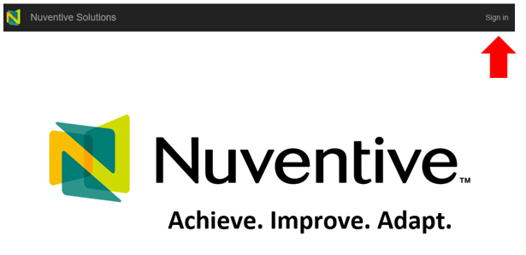
Figure 1. Nuventive login screen with "Sign In" option highlighted.

Navigating the Home Screen
The Nuventive AMS Home Screen is designed to show you what parts of the assessment reporting process you still need to complete for a selected program in a given reporting year. Keep in mind that you are reporting both results from the previous year and plans for the coming year.
Important: The Nuventive AMS interface updates hourly, so you might not see changes reflected immediately. It’s a best practice to check the Home Screen often to make sure it displays your changes. If your changes aren’t reflected after an hour and you have refreshed your browser, contact your Assessment Liaison (opens in new window) or call the OPAIR office, (814) 863-8721, for assistance.
The Home Screen updates its reference years annually in January to focus on the coming year’s assessment report. For example, on December 10, 2021, it will reflect the status of your 2020-21 assessment efforts and plans for 2021-22, and on January 10, 2022, it will reflect the status of your 2021-22 assessment efforts, and your plans for 2022-23.
On the Home Screen, a red X indicates an incomplete part of your annual reporting requirement. A green √ (checkmark) indicates your program assessment complies with that University requirement.
The Program field at the top allows you to navigate between the different programs you have access to (including the Training Exemplar program provided as a reference) (Figure 2). Each time you log in to the AMS, this field automatically populates with the program you worked on the last time you were logged in. Click your cursor anywhere in this field to display a drop-down menu of programs to which you have access and click a program to select it. If you don’t see a program to which you think you should have access, contact your Assessment Liaison (opens in new window) or call the OPAIR office, (814) 863-8721, for assistance.
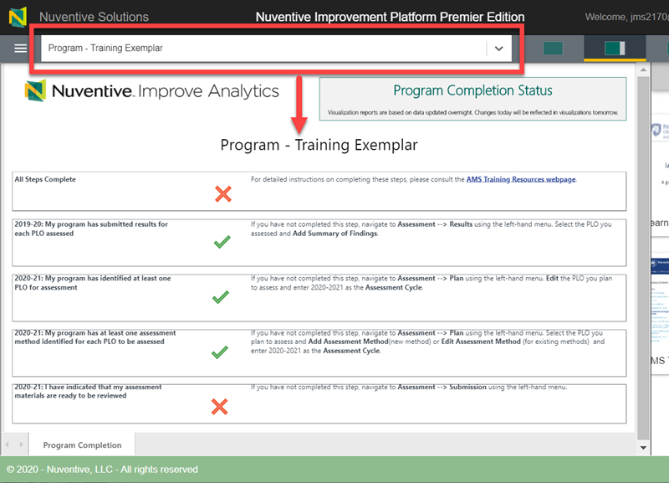
Figure 2: The Nuventive AMS Home Screen for the Program - Training Exemplar, indicated in the Program field and on the Home Screen dashboard.

The Side Panel
The right-side panel of your screen gives you access to a variety of resources, including the LOA Handbook and the AMS Training website. This allows you to use the AMS side-by-side with the assessment resources (Figure 3).
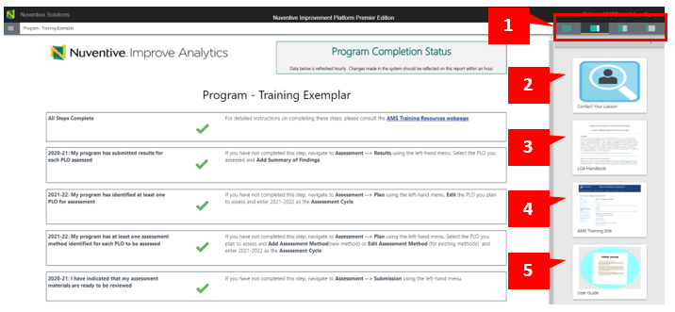
Figure 3: The AMS side panel is present on most screens.

Side panel selections:
- Click the thumbnails to change how much of the side panel you wish to see. By default, when you log in you will always see the third option from the right selected.
- Contact your Liaison provides a list of Assessment Liaisons by campus and college.
- The LOA Handbook provides in-depth learning outcomes assessment explanations and definitions, as well as the option to simultaneously view the AMS and the handbook side-by-side. Look at specific segments or download the full version on this page. Once you click the handbook, you may need to scroll down to see its contents.
- The AMS Training Site provides access AMS training materials and opportunities.
- The User Guide provides access to this document.

Icons
In the top-left corner of many of the AMS screens, you will see four icons (Figure 4). These icons do not appear on every page, nor are they relevant on every page.
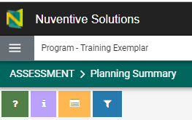
Figure 4. AMS Icons are present on many, but not all, AMS screens.

- Help: This icon displays navigational tips at the top of your current page. Click the X in the help box to exit this view.
- Instructions: This icon displays instructions at the top of the page, if applicable. Instructions display automatically only if there are instructions in the system for a certain page. Not every page has instructions. Click the X in the instructions box to exit this view.
- Audit Log: This icon shows a log of any edits or changes made to the current page. It shows when changes were made and who made them. Click on the Edit type to see the Activity Details of what was changed. Click the X in the Audit Log box to exit this view.
- Filter: This icon displays filter options available on certain pages to help you narrow your search. If you have filters applied to a page, this icon has a red glow around it (Figure 5). Filters are user specific. If multiple users have access to your program, each user can set different filters to customize their view.
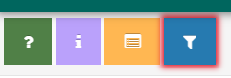
Figure 5: The Filters icon with a red glow around it, indicating active filters.
To remove filters, click the Filters icon and click the Clear Filters button in any Filters Settings section to which filters are applied (Figure 6). You may need to scroll down to see all the instances in which settings are applied. Click the X in the upper right-hand corner of the Filters box to exit the filters view.

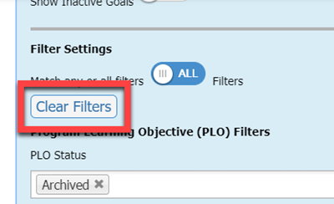
Figure 6: The Clear Filters button.

Special Note on Filters
The option to “Match any or all filters” comes into play when you are filtering on multiple fields (Figure 7). “Any” will return results that match at least one of your filters, while “All” will only return results that match all your filters. For example, if you filtered by reporting period “2018-19” and by “Active” outcomes only, “Any” would return outcomes and results that have either the 2018-2019 for the reporting period OR an Active outcome. “All” would return only those outcomes at are Active AND have a report year of 2018-2019.
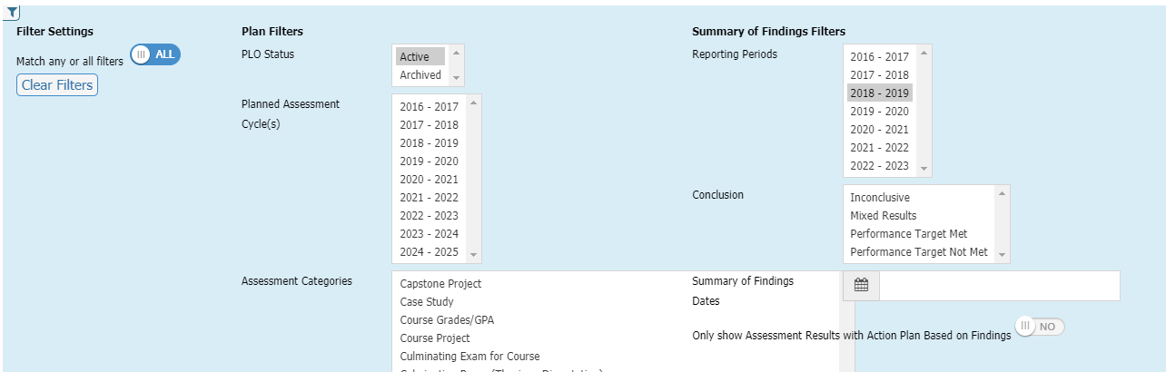
Figure 7. The filter “any” or “all” option.

Using the AMS

Finding your Program(s) and Accessing the Menu
- Navigate to the AMS website (opens in new window) and click the AMS LOGIN button and log in with your PSU credentials, if necessary.
- Click the Program field at the top of your screen and select a program from the drop-down menu (Figure 8). This drop-down menu only displays programs to which you are assigned. If a program is missing, please contact your Assessment Liaison (opens in new window) or call the OPAIR office, (814) 863-8721, for assistance.
- Click the hamburger icon (three lines) in the upper left-hand corner to expand the collapsed menu.
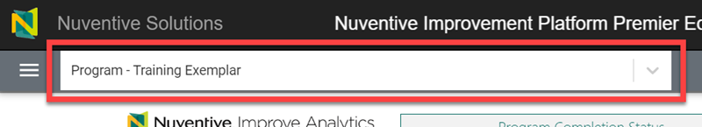
Figure 8: The Program field.

General Information
Important: The first time you access a program in the AMS, please review your program’s General Information for accuracy. If corrections are needed, contact your Assessment Liaison.
- Click the Program tab from the drop-down menu.
- Click the General Information subtab under the Program tab (Figure 9).
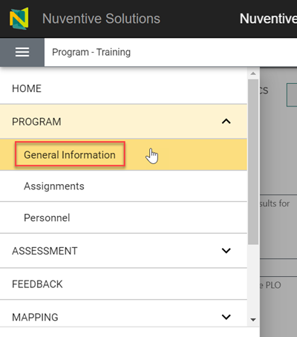
Figure 9: The General Information subtab.

Program - Training Exemplar
Use the Program – Training Exemplar to explore view-only access to the Nuventive Improve AMS interface and see what types of information are expected in the various fields. All Assessment Leaders should have access to the Training Exemplar. To find the Program – Training Exemplar instance in the AMS, click anywhere in the program field at the top of the screen. Scroll through the drop-down menu that opens and select the Program – Training Exemplar. Click through the program to observe how completed assessments should look. Note that you cannot change anything about this program as it for illustrative purposes only and the program is fictitious.

Find a Personnel List for Your Program
- Click the Program tab from the drop-down menu.
- Click on the Personnel subtab under the Program tab (Figure 10) to view a list of people in the Personnel Report who have access to your program in the AMS (Figure 11).
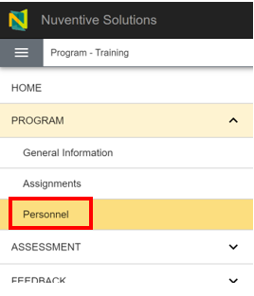
Figure 10. The Personnel tab.

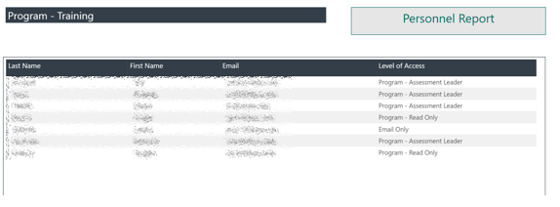
Figure 11. The Personnel report.

Program Planning Summary
While the Home Screen indicates the status of tasks required for your annual assessment reporting, the Program Planning Summary provides a basic rundown for the program selected in the Program field. It shows your Program Learning Objectives (PLOs), and how many Assessment Methods, Assessment Results, and Action Plans Based on Findings you have for that program.

Find the Program Planning Summary
- Click the Assessment tab from the drop-down menu.
- Click the Planning Summary subtab under the Assessment tab (Figure 12) to go to your selected Program Planning Summary.
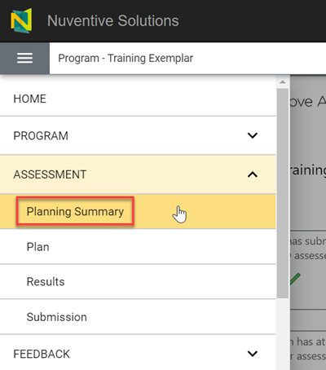
Figure 12: The Planning Summary subtab.

Navigate the Program Planning Summary
Use this diagram (Figure 13) to navigate the Planning Summary.
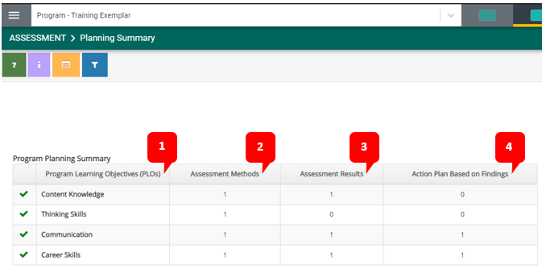
Figure 13: A diagram of the Planning Summary for a program in the AMS.
- Program Learning Objectives (PLOs): This column shows your PLOs listed for this specific program. This page will only show active PLOs and values for active assessment methods. A green checkmark indicates that you have successfully entered a PLO into the system and the table summarizes the information related to that PLO. However, the Summary table does not indicate whether you have completed the necessary tasks for your annual assessment. You should refer to your Home Screen to determine any outstanding reporting items for the year.
- Assessment Methods: This column shows how many active Assessment Methods there are for each PLO
- Assessment Results: This column shows how many Assessment Results there are for each PLO.
- Action Plan Based on Findings: This column shows how many Action Plans there are for each PLO.

Program Learning Objectives (PLOs)
The University requires that every academic program articulate Program Learning Objectives (PLOs). These should be reviewed as part of each annual assessment submission. PLOs are objectives for your program designed to specify the expected capabilities and knowledge students gain from engaging with that program.

Find Your PLOs
- Click the Assessment tab from the drop-down menu.
- Click the Plan subtab under the Assessment tab (Figure 14). This takes you to your Plan page for your program’s PLOs.
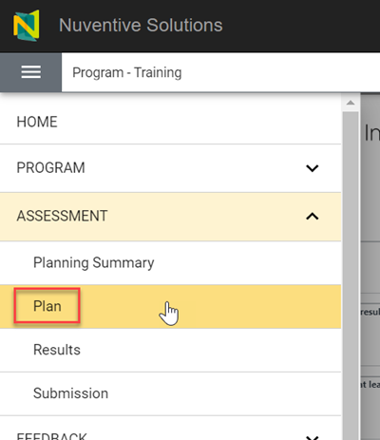
Figure 14: The Plan subtab.

Add a PLO
Important: Each PLO should be entered a single time in the AMS. Do not create new versions of the same PLO each time you assess. Assessment years can be indicated in the Assessment Cycle(s) field.
- Navigate to the Plan subtab in the menu (Steps 1-2 under Find Your PLOs).
- Click the green circle with a plus sign 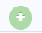 at the right side of the Program Learning Objectives (PLOs) displayed (Figure 15).
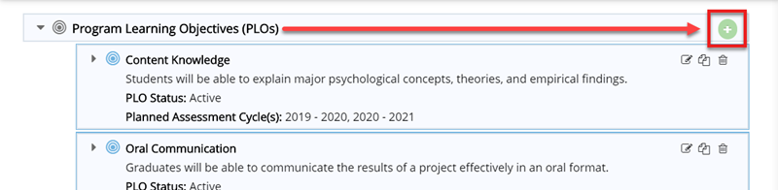
Figure 15: The green circle with a plus sign to add a PLO.
- Enter information in the fields displayed. If you’re not sure what to enter, click the blue circles with question marks next to the fields to see greater detail (Figure 16). An asterisk (*) indicates required fields.
Important: We strongly discourage using numbers in your PLO names (e.g., PLO 1, PLO 2), as this could create confusion later if you need to rearrange PLOs or as new PLOs are added and old ones archived.
Note: If you do not select a status from the PLO Status drop-down menu, the PLO defaults to active status. Active PLOs are those currently in effect for your program. Archived PLOs are PLOs that were once used but are no longer current.
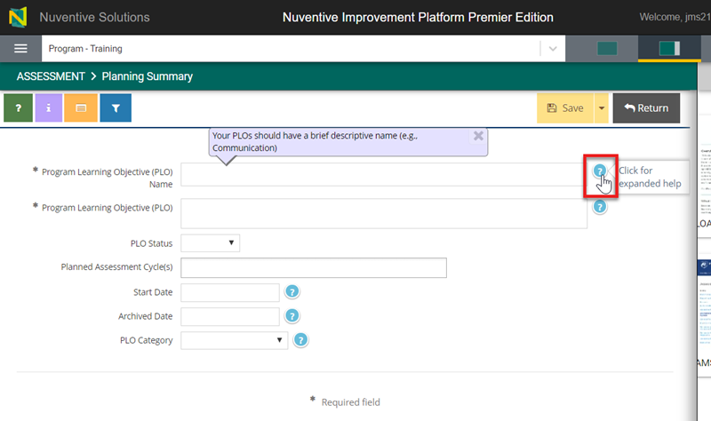
Figure 16: The blue help circles provide details about the fields.
- Please select the PLO Category that best fits your PLO. The options are Application, Communication, Create, Critical Thinking, Cultural Competence, Ethics, Knowledge, Professional, Research, Teamwork, or Other.
- To save your PLO, there are multiple options:
  - Click the Save button to save your PLO and remain on that page to make edits (Figure 17).
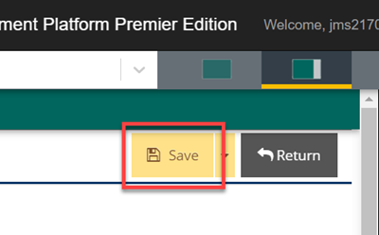
Figure 17: The Save button.
  - Click the arrow to the right of the Save button and select Save and Return to save your PLO and return to the Plan page (Figure 18).
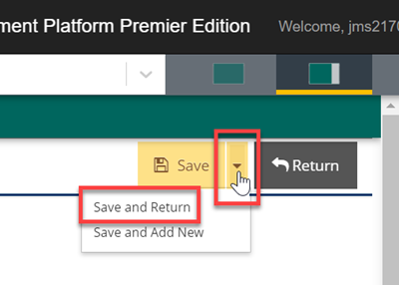
Figure 18: The Save and Return option.
  - Click the arrow to the right of the Save button and select Save and Add New to save your new PLO and add another PLO (Figure 19).
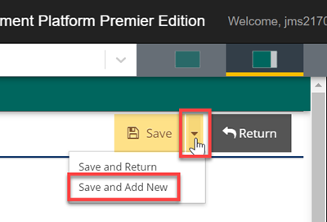
Figure 19: The Save and Add New option.
- If you did not choose the second option (Save and Return) and have finished adding the PLO(s), click the Return button. Your PLO is now added to the bottom of the list of PLOs on the Plan page.

Flag a PLO for Assessment
One of the benefits of the AMS is that you don’t have to type in the same information year after year. To indicate your plan to assess a PLO in any given year, you need only edit the PLO and add that year to the Assessment Cycle(s) field.
Important: The Assessment Cycle(s) field should include all prior assessment years, as well as future years where assessment is anticipated (this can always be edited if plans change.)

Edit PLOs
Important: Archive any PLOs that are no longer current for the program rather than editing or deleting them. Editing PLOs used in previous assessment years changes those PLOs to the new (edited) version. To avoid this, we recommend first archiving the PLO that is no longer currently active and then adding a new active PLO in its place. PLOs should only be edited or deleted in consultation with your Assessment Liaison.
- Navigate to the Plan subtab in the drop-down menu (Steps 1-2 in Find Your PLOs).
- Click the Edit PLO icon to the right of the PLO to edit information for this PLO (Figure 20).
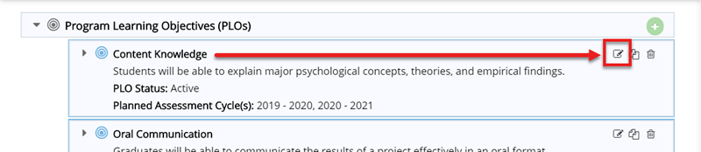
Figure 20: The Edit PLO icon.
- Click the down arrow next to the Save button and select Save and Return to return to the Plan page (Figure 21). A green message box displays at the upper right-hand corner of the screen to confirm your changes were successfully saved.
Figure 21: The Save and Return option.

Rearrange PLOs
Important: Make sure to clear all filters before rearranging your PLOs. You cannot arrange PLOs if you have any active filters. The Filters icon has a red glow around it if you have filters applied (Figure 22).
Figure 22: The Filters icon with a red glow around it, indicating active filters.
- Navigate to the Plan subtab in the drop-down menu (Steps 1-2 in Find Your PLOs).
- Hover your cursor over the blue bullseye icon to the left of the PLO that you wish to rearrange. When your cursor changes to a four-way arrow , click and drag the PLO such that the PLOs are in the desired order.

Archive and Delete PLOs
Important: We recommend that you DO NOT DELETE your PLOs. Rather, you should archive any PLO that is no longer current. If you have PLOs used in previous years, deleting them will delete everything related to those PLOs (including methods and previous assessment findings) and they may not be recoverable. A good instance for using the delete function would be if someone on your team created a duplicate PLO for one you already have in your program. In this example you would delete the duplicate.
PLOs should only be archived if they are no longer relevant to your program. Archiving is NOT a way to indicate that you are not assessing a PLO in a particular year. See Flag a PLO for Assessment for more information.

Archive a PLO
- Navigate to the Plan subtab in the drop-down menu (Steps 1-2 under Find Your PLOs).
- Click the Edit PLO icon to the right of the PLO you wish to archive (Figure 23).
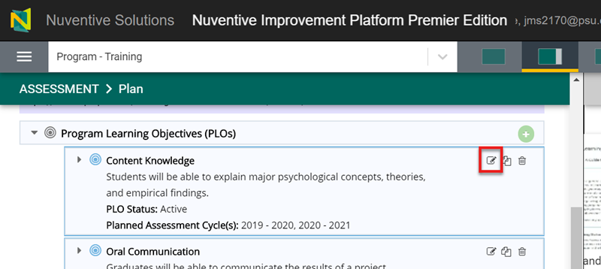
Figure 23: The Edit PLO icon.
- Click the PLO Status drop-down and select Archived (Figure 24).
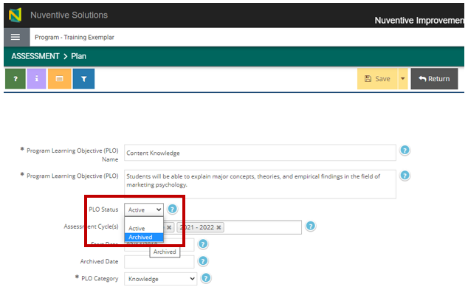
Figure 24: The PLO Status field drop-down menu.
- (Optional) Click the Archived Date field to select a date. This attaches a date to the archived PLO to indicate when it was archived. OPAIR recommends completing this field for future reference, though it is not required.
Important: Setting the Archived Date does not automatically change the PLO Status.
- Click the arrow to the right of the Save button and select Save and Return to save your PLO and return to the Plan page (Figure 25).
Figure 25: The Save and Return option.
- A green message box in the upper right-hand corner confirms that your changes were saved. You can see your archived PLO on the Plan page (Figure 26).
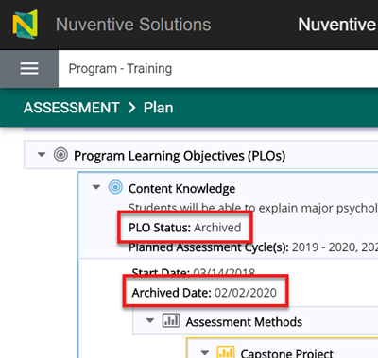
Figure 26: An Archived PLO with its Archived Date.

Delete a PLO
Important: Although this is an option in the AMS, we strongly recommend that you DO NOT DELETE your PLOs and instead archive them if you no longer wish to use them. If you have PLOs used in previous years, deleting them will delete everything related to those PLOs (including previous assessment findings) and they may not be recoverable. A good instance for using the delete function would be if someone on your team accidently created a duplicate PLO for one you already have in your program. In this example you would delete the duplicate.
- Navigate to the Plan subtab in the drop-down menu (Steps 1-2 under Find Your PLOs).
- Click the trash can icon to the on the right-hand side of the PLO you wish to delete. A prompt appears asking you to confirm that you want to delete that PLO.
- Click OK to delete the selected PLO.
- A green message box in the upper right-hand corner confirms your deletion. The deleted PLO no longer appears with your program, or in past yearly submissions if it was part of them.

Assessment Methods
Assessment Methods are the strategies, tools, and exercises used to measure student outcomes related to a PLO and are a required part of your annual submission.

Add an Assessment Method to a PLO
- Navigate to the Plan subtab in the drop-down menu (Steps 1-2 in Find Your PLOs).
- From the Program Plan table, click on the triangle next to the PLO of interest to expand the PLO and see any Assessment Methods already on record for this PLO (Figure 27).
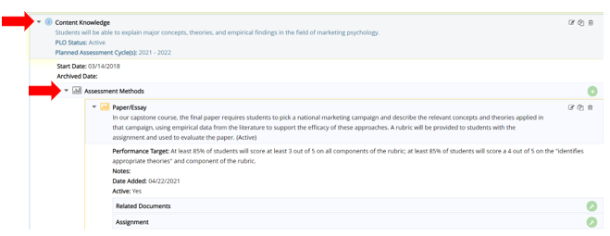
Figure 27: Assessment Methods in the Program Plan screen.
- Click the Add an Assessment Method icon (a green circle with a plus sign inside) to the right of the Assessment Methods section (Figure 28).
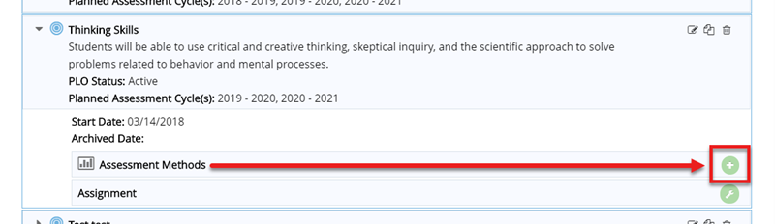
Figure 28: The Add an Assessment Method icon to the right of the Assessment Methods for a PLO.
- Enter information in the fields relevant to your Assessment Method. Click the blue help circle with a question mark next to each field for help with that field (Figure 29). Required fields are indicated with an asterisk (*).
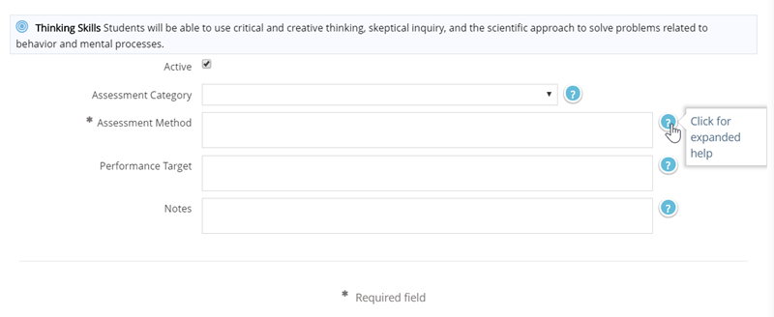
Figure 29: The blue help circles.
- To save your Assessment Method you have several options:

  - Click the Save button to save your Assessment Method and remain on that page to make edits (Figure 30).
Figure 30: The Save button.
  - Click the arrow to the right of the Save button and select Save and Return to save your Assessment Method and return to the Plan page (Figure 31).
Figure 31: The Save and Return option.
  - Click the arrow to the right of the Save button and select Save and Add New to save your new Assessment Method and add another Assessment Method for that PLO (Figure 32).
Figure 32: The Save and Add New option.
- If you did not choose the second option (Save and Return) and have finished adding your Assessment Method, click the Return button to return to the Plan page.
- A green message box displays in the upper right-hand corner to confirm your Assessment Method was successfully saved. Your new Assessment Method now displays in the information for the corresponding PLO on the Plan page, under Assessment Methods (Figure 33).
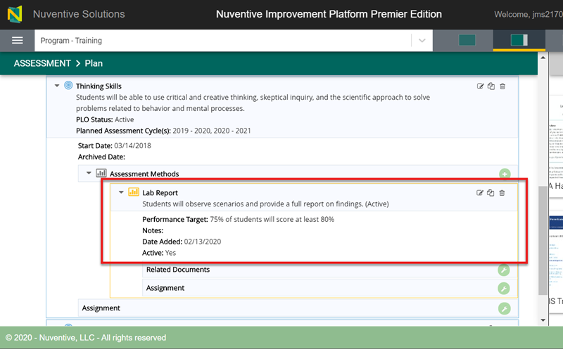
Figure 33: An added Assessment Method in a PLO.

Important: Each Assessment Method for a PLO should be entered a single time in the AMS. Do not create new versions of the same Assessment Method each time you assess a given PLO using that Assessment Method. When you enter Results, you will have the opportunity to tie these to a particular Reporting Year.

Edit an Assessment Method
Important: Editing an Assessment Method changes how the method appears for each year in which it was used, not just the current year forward. Use Edit to add clarification/detail to an existing method. If you are using a different Assessment Method – even if it is similar to the old method – then make the old Assessment Method inactive (Active and Inactive Assessment Methods) and enter a new one.
To edit a method:
- Navigate to your Assessment Methods (steps 1 and 2 in Add an Assessment Method to a PLO).
- Click the Edit Assessment Method icon to the right of the Assessment Method you wish to edit (Figure 34).
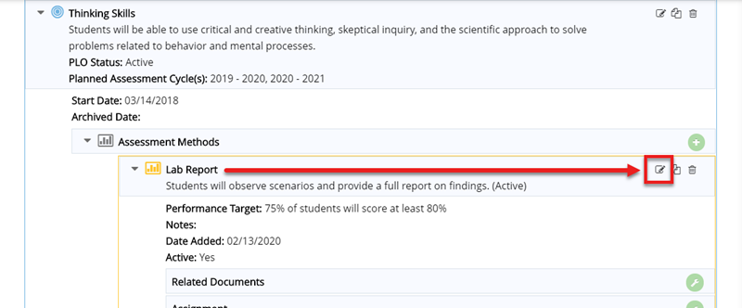
Figure 34: The Edit Assessment Method icon to the right of an Assessment Method.
- Edit the information in the fields provided. Click the blue help circle with a question mark next to each field for help with that field (Figure 35).
Figure 35: The blue help circles.
- Click the down arrow next to the Save button and select Save and Return to return to the Plan screen (Figure 36).
Figure 36: The Save and Return option.
- A green message box in the upper right-hand corner confirms that your Assessment Method was successfully saved. Your updated Assessment Method now shows in the information for the corresponding PLO on the Plan page, under Assessment Methods.

Active and Inactive Assessment Methods
Assessment Methods are activated or “active” by default. An active Assessment Method is one you’re currently using or plan to use in the future for your curriculum. An inactive Assessment Method is one that you no longer anticipate using (though you may reactivate it for use in future cycles).

Make an Assessment Method Inactive
This section demonstrates how to make an Assessment Method inactive in the AMS. You should make an Assessment Method inactive if you’re adding a new one to replace it or simply no longer use it.
Important: Make Assessment Methods you no longer wish to use inactive rather than deleting them.
- Navigate to your Assessment Methods (steps 1 and 2 in Add an Assessment Method to a PLO).
- Click the Edit Assessment Method icon to the right of the Assessment Method you wish to edit (Figure 37).
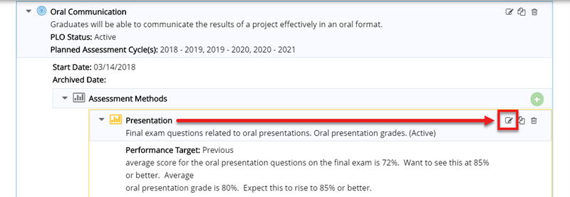
Figure 37: The Edit Assessment Method icon to the right of an Assessment Method.
- Deselect the Active checkbox to make the Assessment Method inactive (Figure 38).
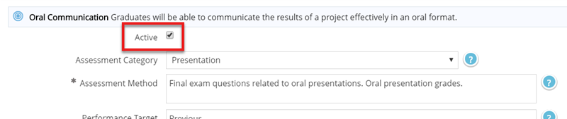
Figure 38: The Active checkbox.
- Click the down arrow next to the Save button and select Save and Return to return to the Plan page (Figure 39).
Figure 39: The Save and Return option.
Inactive Methods will not be counted in your Program Planning Summary table and will not display on your Plan page.

Activate an Inactive Assessment Method
In most circumstances, inactive Assessment Methods will not display with your active Assessment Methods on the Plan page. These instructions demonstrate how to locate and reactivate your inactive Assessment Method.
- Navigate to your Assessment Methods (steps 1 and 2 in Add an Assessment Method to a PLO).
- Click the Filters icon in the upper left-hand corner of the screen to open the Filters window.
Scroll to the bottom of the Filters window to Assessment Method Filters and click the Show Inactive Assessment Methods toggle switch to set it to YES (Figure 40). The Filters icon has a red glow around it if you have any filters applied (Figure 41).
- Any inactive Assessment Methods display under its PLO in the Plan page.
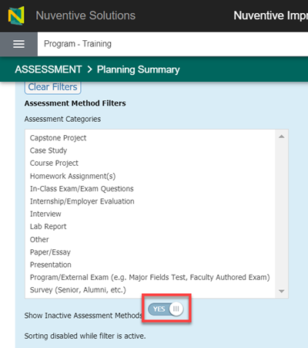
Figure 40: The Show Inactive Assessment Method toggle switch.
Figure 41. The Filters icon with a red glow around it, indicating active filters.
- Click the X in the upper right-hand corner of the Filters window to close the Filters window. Alternatively, scroll down to view your PLOs and any inactive Assessment Methods with the Filter window open.
- Click the Edit Assessment Method icon to the right of the inactive Assessment Method that you wish to edit (Figure 42).
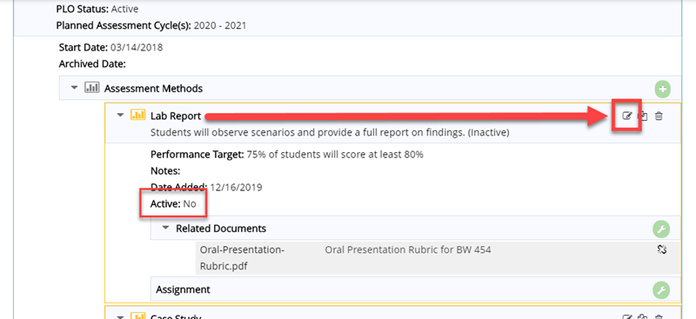
Figure 42: The Edit Assessment Method icon to the right of an inactive Assessment Method.
- Select the Active checkbox to activate the Assessment Method (Figure 43).
Figure 43: The Active checkbox.
- Click the down arrow next to the Save button and select Save and Return to return to the Plan page (Figure 44).
Figure 44: The Save and Return option.
Your Assessment Method is now active in your Plan and displays under your Assessment Methods.
Important: Be aware of any filters you have in place. You may need to clear them if things seem to be missing. To clear the Assessment Method Filters, click the Filters icon again then navigate to the Assessment Method Filters section and click the Clear Filters button.

Reorder Assessment Methods
If your Assessment Methods are not appearing in the order you would like to see them in, you can reorder them.
- Navigate to your Assessment Methods (steps 1 and 2 in Add an Assessment Method to a PLO).
- Make any inactive Assessment Methods visible by clicking the Filters icon. Then click the Show Inactive Assessment Methods toggle switch to set it to YES (Figure 40; steps 1 and 2 in Activate an Inactive Assessment Method). You cannot reorder your Assessment Methods without taking this step.
- Then hover over the method you want to move until you get the 4-sided arrow and drag it into the appropriate position (Figure 45).
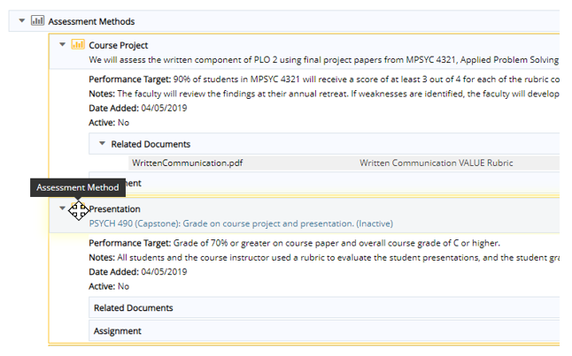
Figure 45: Re-ordering an assessment method.

Delete an Assessment Method
Important: We strongly recommend making Assessment Methods inactive, rather than deleting them. If you must delete an Assessment Method, you must first delete any Assessment Results related to it.
- Navigate to your Assessment Methods (steps 1 and 2 in Add an Assessment Method to a PLO).
- Click the Delete Assessment Method (trash can) icon to the right of the Assessment Method you wish to delete (Figure 46).
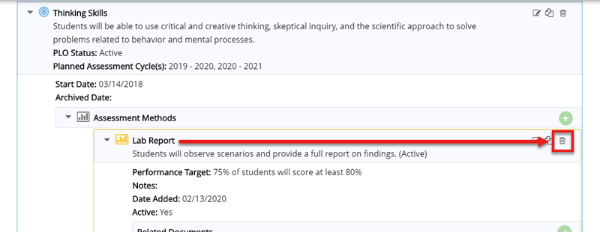
Figure 46: The Delete Assessment Method icon to the right of an Assessment Method.
- A prompt displays asking you to confirm you want to delete the selected Assessment Method. Click OK to delete the Assessment Method.
- A green message box displays to confirm your Assessment Method was deleted successfully.

Relate a Document to an Assessment Method
This section shows how to relate a document (i.e., add an attachment) from your Document Repository to your Assessment Method. This process assumes you have folders and files set up in your Program’s Document Repository.
See these instructions to complete these prerequisite steps:
- Add a Folder to the Document Repository
- Add File or URLs to the Document Repository
To Relate Document:
- Navigate to your Assessment Methods (steps 1 and 2 in Add an Assessment Method to a PLO).
- In the Assessment Method to which you wish to attach an item, click the Relate Document icon (a green circle with a wrench in the center) to the right of Related Documents (Figure 47).
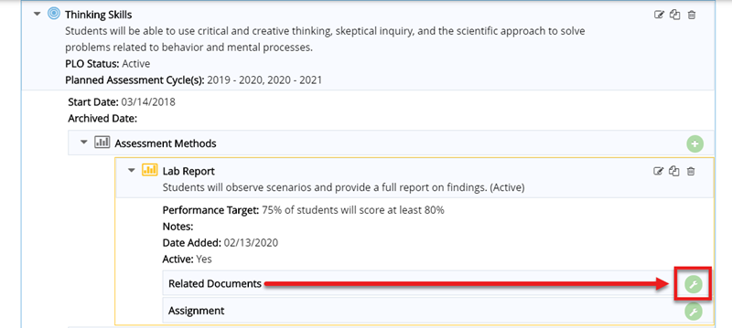
Figure 47: The Relate Document icon to the right of Related Documents.
- Select the folder within the Document Repository that contains the document you want to attach to the Assessment Method (Figure 48).
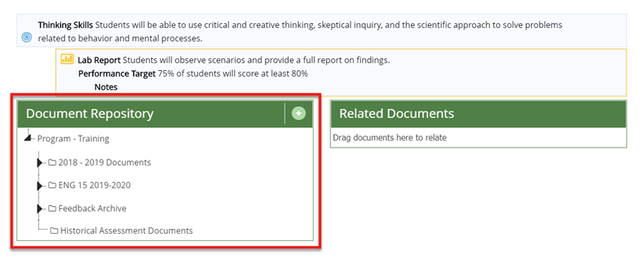
Figure 48: The list of folders from the Document Repository.
- Locate the file or item you wish to attach to the Assessment Method. You can click and drag the file to the Related Documents section to attach it. You can also hover your cursor over the file name and click the down arrow to the right of the file name. This opens a menu that lets you relate the document, preview the file, or download the file (Figure 49). A green message box confirms your document was attached or “related” successfully.
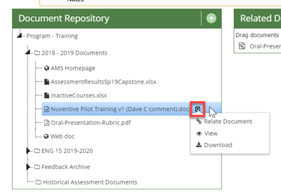
Figure 49: The down arrow to the right of a file name.
- Click the Complete button in the upper right-hand corner of the screen to return to the Assessment Method.
- Your file now appears in the Related Documents section of the Assessment Method.
To remove the file or item from the Assessment Method, click the Un-relate Document icon (broken chain link) to the right of the related document (Figure 50). When prompted, click OK to confirm that you want to remove or “un-relate” the linked document. A green message box in the upper right-hand corner confirms the removal.
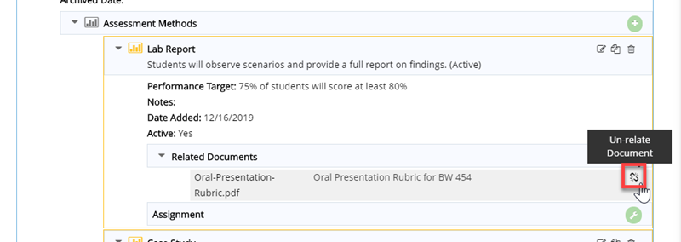
Figure 50: The Un-relate Document icon.

Assessment Results
Assessment Results are the findings of the Assessment Methods and are used to evaluate your program’s success related to its learning goals.
Important: If you have no results for an Assessment Cycle, do not enter anything (e.g., “NA”, “None”, “No results”) on the Results page. You will have the opportunity to explain why you had no results on the Submission screen.

Add an Assessment Result
Important: New results should be added every year that you assess a given PLO. You should not edit prior results to add a new set of findings.
- Click the Assessment tab from the drop-down menu.
- Click the Results subtab under the Assessment tab (Figure 51).
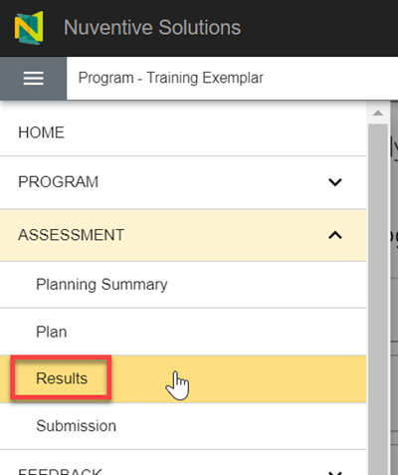
Figure 51: The Results subtab.
- Click the arrow to the left of each PLO to see its Assessment Method(s).
- Click the Add Summary of Findings icon (a green circle with a plus sign inside) to the right of the Assessment Method to which you want to add results (Figure 52).
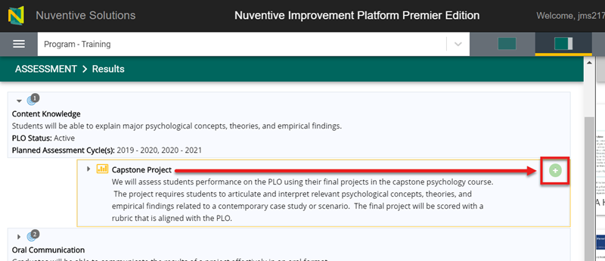
Figure 52: The Add a Summary of Findings icon to the right of the Assessment Method to which you want to add results.
- Enter information in the fields provided. If you’re not sure what to enter, click the blue help circle with a question mark next to each field for help with that field. Required fields are indicated with an asterisk (*). You can also visit the “Program – Training Exemplar” to see an example of what type of information goes in these fields (see Program – Training Exemplar for navigation).
- Click the down arrow next to the Save button and select Save and Return to return to the Results page (Figure 53).
Figure 53: The Save and Return option.
- A green message box in the upper right-hand corner confirms that your Assessment Results were successfully saved. Your updated Assessment Results now show in the Results page under the Assessment Method (Figure 54).
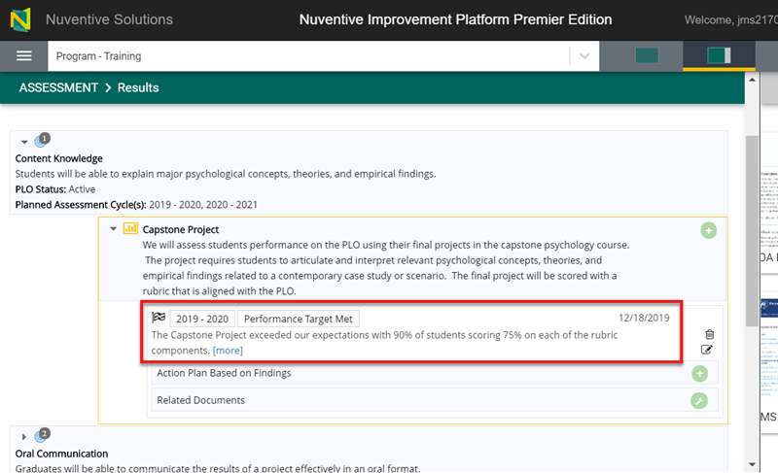
Figure 54: Assessment Results for an Assessment Method.

Edit an Assessment Result
Important: If entering new results based on an existing Assessment Method, do not edit your old results to add the new findings. Instead, add a new set of results for the appropriate year (Add an Assessment Result).
To edit an existing result, complete the following steps.
- Click the Assessment tab from the drop-down menu.
- Click the Results subtab under the Assessment tab (Figure 55).
Figure 55: The Results subtab.
- Click the arrow to the left of the PLO and Assessment Method to expand and see any existing Assessment Results. A number over the blue bullseye next to the arrow indicates how many active Assessment Results are present (Figure 56).
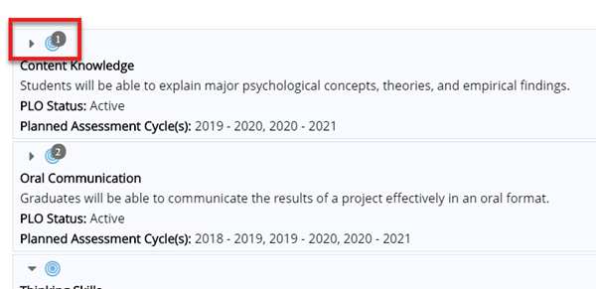
Figure 56: The number over the blue bullseye indicates the number of Assessment Results for that PLO.
- Your Assessment Results display on the screen, each indicated by a small, checkered flag. Each result shows the date the result was entered, the assessment year, the conclusion, and a brief expandable summary (Figure 57).
Figure 57: An Assessment Result for an Assessment Method.
- Click the Edit Summary of Findings icon on the right side of the Assessment Result (Figure 58).
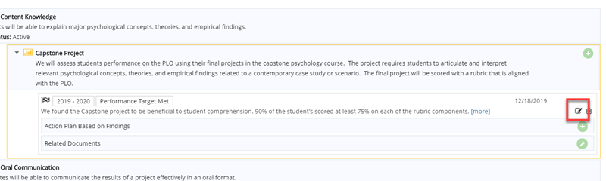
Figure 58: The Edit Summary of Findings icon to the right of the Assessment Result.
- Edit the fields you wish to change.
- Click the down arrow next to the Save button and select Save and Return to return to the Results page (Figure 59).
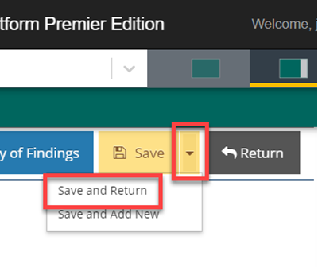
Figure 59: The Save and Return option.

Move an Assessment Result
You may find it necessary to move an assessment result if you accidently post it under the wrong PLO.
- Navigate to your Assessment Results.
- Click the Edit Summary of Findings icon on the right side of the Assessment Result (Figure 60).
Figure 60: The Edit Assessment Results icon to the right of an Assessment Result.
- Click the Move Summary of Findings button at the top of the screen (Figure 60).
- Click your cursor in the Program Learning Objective (PLO) Name field to open a drop-down menu (Figure 61).
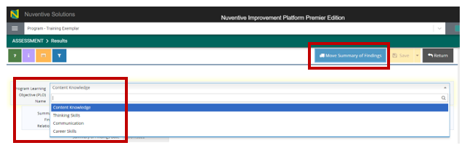
Figure 61: The Move Summary of Findings button.
- Select the PLO in the drop-down menu to which you wish to move the Assessment Result.
- Click the Move Summary of Findings button again.
- Click the down arrow next to the Save button and select Save and Return to return to the Results page (Figure 62).
Figure 62: The Save and Return option.

Delete an Assessment Result
Important: You should only delete Assessment Results entered erroneously. Consider moving or Edit an Assessment Result the Assessment Result first.
- Navigate to your Assessment Results.
- Click the Delete (trash can) icon on the right side of the Assessment Result you wish to delete (Figure 63).
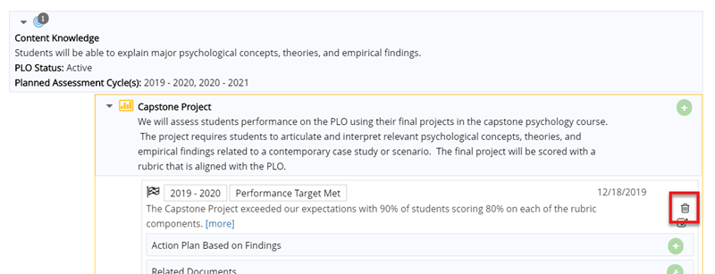
Figure 63: The Delete Summary of Findings icon to delete an Assessment Result.
- A prompt asks you to confirm that you want to delete the selected Assessment Result. Click OK to delete the Assessment Result.

Relate a Document to an Assessment Result
You can relate (or unrelate) a document to an Assessment Result (Figure 64) in the same way that you relate a document to an Assessment Method (Relate a Document to an Assessment Method).
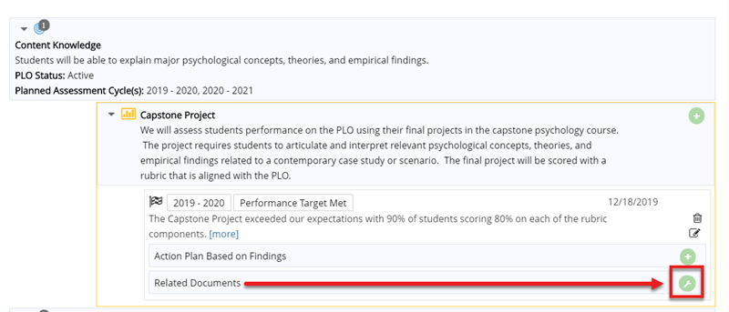
Figure 64: The Relate Document icon to the right of the Related Documents for an Assessment Result.

Action Plans Based on Findings
An Action Plan Based on Findings is any course of action you plan to take for your program based on your Assessment Results.
Important: Your action plan may be to “stay the course” if students are meeting your goals.

Add Action Plan
- Navigate to your Results.
- Click the green circle with a plus sign to the right of Action Plan Based on Findings under the relevant Result (Figure 65).
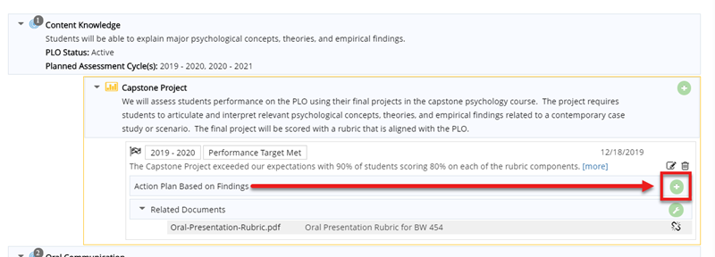
Figure 65: The Add Action Plan Based on Findings icon.
- Enter information in the fields provided. If you’re not sure what to enter, click the blue help circle with question mark next to the ‘Action Plan Based on Findings’ field for help with that field. Required fields are indicated with an asterisk (*).
- Save your Action Plan and Return.
- Your new Action Plan Based on Findings now shows in the information for the corresponding PLO on the Results page, under an Assessment Result (Figure 66).
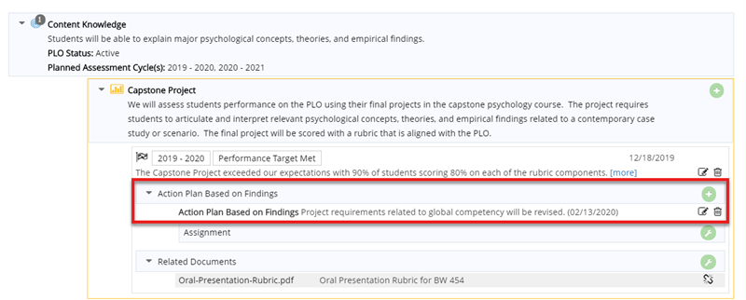
Figure 66: An Action Plan Based on Findings for an Assessment Result.

Edit Action Plan
- Navigate to your Action Plan and click the Edit Action Plan Based on Findings icon on the right-hand side of the Action Plan Based on Findings entry (Figure 67).
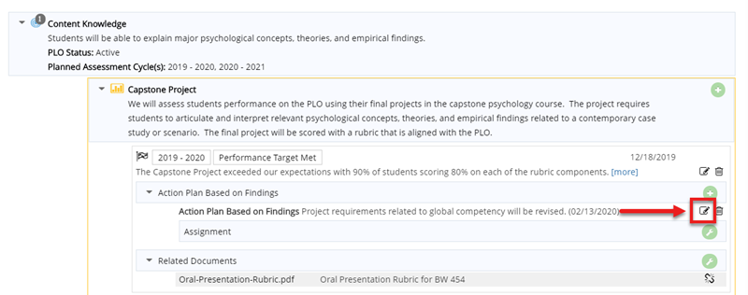
Figure 67: The Edit Action Plan Based on Findings icon.
- Edit the content in the fields you wish to change and save.

Delete an Action Plan
- Navigate to your Action Plan and click the Delete Action Plan Based on Findings icon (the trash can icon) on the right-hand side of the Action Plan Based on Findings entry (Figure 68).
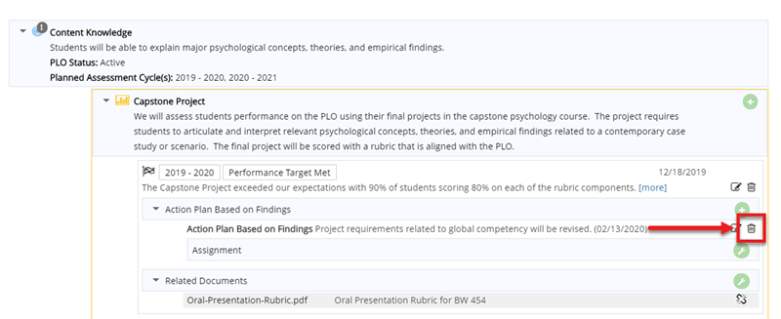
Figure 68: The Delete Action Plan Based on Findings icon.
- A prompt displays to confirm your deletion. Click OK to delete that Action Plan Based on Findings.

Annual Report Submission
Before you complete your annual submission, you need to ensure the following list is complete:
- Enter Assessment Results and Action Plan(s) for the previous academic year.
- Indicate which PLOs you will be assessing and how (i.e., the Assessment Method) in the coming academic year.
Completing the submission screen lets OPAIR know your annual report is ready for review. You can check the level of completion of your submission on the Home Screen.
Important: Your report is not considered final until you go through the submission process. You must submit even if you are not submitting results for the previous academic year. The submission screen will allow you to provide a reason that you have no results.
To submit your report:
- Click the Submission subtab under the Assessment tab (Figure 69).
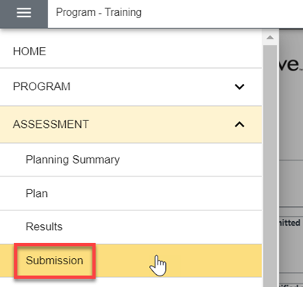
Figure 69. The Submission subtab.
- Click the Add icon (plus sign in a circle) in the upper right corner or in the center, to add your submission (Figure 70).
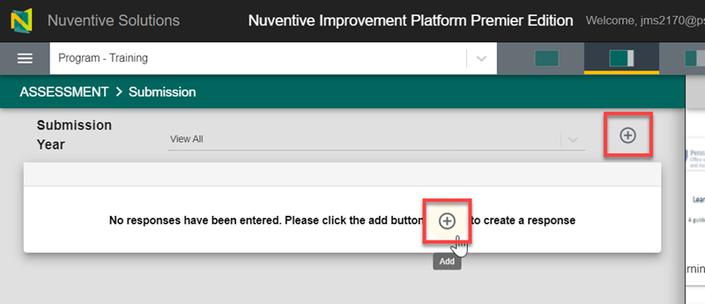
Figure 70. The Add icon for a submission.
- Click your cursor in the Submission Year field and select a cycle year (Figure 72). Note that the Submission Year is the academic year for which you are reporting results (e.g., if you are submitting in June 2020, the Submission Year would be 2019 – 2020). If you have completed all prior submission years, the form will default to the current year.
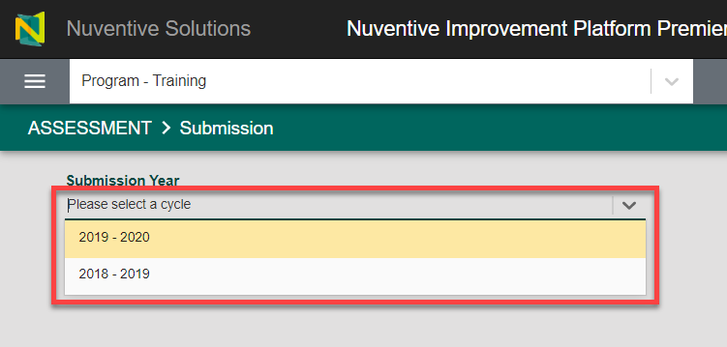
Figure 71. The Submission Year selection.
Required fields on the Annual Plan Submission page are designated with an asterisk (*) (Figure 89).
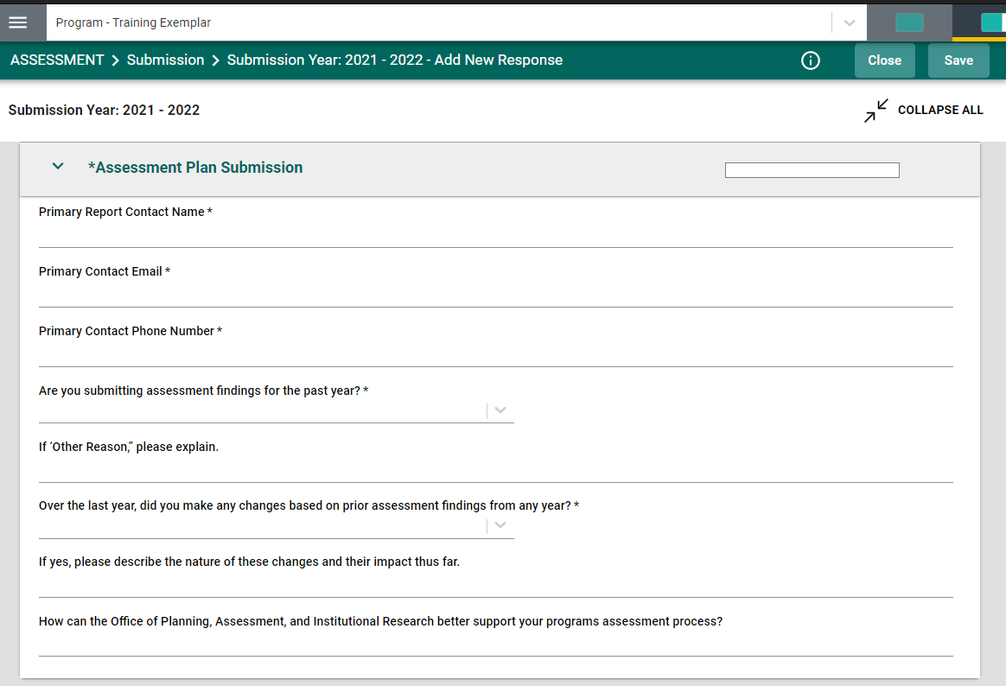
Figure 72. The Assessment Plan Submission Page.
- The Primary Report Contact should be the person who can answer questions about the program and its assessment.
- If you have no results for the prior academic year, you will be given a chance to indicate this and give a reason.

Important: If you are submitting no results for the previous academic year, you must indicate that by selecting a reason. If you select Other, you must select an explanation in the next question in this section.

- When you have completed all the Submission fields, click the Save button in the upper right-hand corner to complete the submission process.
- You can click the Edit icon (pencil icon) to the right of the Submission if you need to edit it after saving. The Edit icon appears after clicking on the ellipsis (three dots icon) to the right of the Submission.
- Click the Delete icon (trash can icon) to the right of the Submission to delete it. The Delete icon appears after clicking on the ellipsis (three dots icon) to the right of the Submission

Document Repository
You may wish to link files such as assignment descriptions and rubrics to your Assessment Methods and Summaries of Findings. The Document Repository allows you to store files and link those files and URLs relevant to your assessment methods and results. This section shows how to find the Document Repository, create a folder, and add files and URLs to that folder. Once you’ve uploaded your file or linked to its URL, you can attach it to various points of the submission process.
Important: Documents must be saved in folders. Use an existing folder or Add a Folder to the Document Repository.
Note: When navigating the Document Repository, it may be helpful to use the breadcrumbs at the top of the Documents page (Figure 73) rather than the Back button on your browser to move between folders.
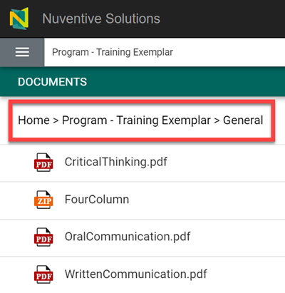
Figure 73: Breadcrumbs in the Document Repository.

Add a Folder to the Document Repository
Important: All documents and URLs must be saved in a folder. Use one of the existing folders or create an appropriate one. Since most programs will use the same documents for multiple assessments (e.g., a rubric), OPAIR recommends that you make folders based on subject area rather than year. So, for example, a communications rubric may be stored in your “Rubric” folder and linked to assessments across multiple years.
- In the menu, click the Documents tab to open the Document Repository (Figure 74).
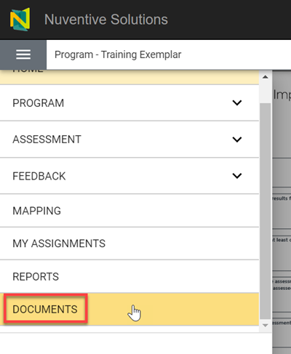
Figure 74: The Documents tab.
- You will see any folders related to your program here. When you first open the Document Repository you will have the General folder present by default. This folder is a good place to store items like course lists for the restricted electives (if your program has any) used in your Curriculum Map. Programs that received assessment feedback from OPAIR in 2019 will also have a Feedback Archive folder.
- Click the Add Folder icon in the upper right-hand corner. A new window opens.
- Enter a name for the folder in the Name field.
- Click the Save button in the lower right-hand corner of the window.
- Your folder appears alphabetically in the list of folders. You can now use that folder to save, add, and view files.

Add Files and URLs to the Document Repository

Add a File from Your Computer
- Navigate to the Document Repository and click the folder to which you want to add a document.
- Click the Add File icon in the upper right-hand corner. A new window opens.
- Click the Choose Files button on the left-hand side of the Add Documents window to select a file from your computer.
- Click the Save button in the lower right-hand corner of the window.
- Your selected file now appears in the list within the folder in alphabetical order. You can now attach it to your Assessment Methods, and Assessment Results.

Add a URL to the Document Repository
If the document you wish to reference is on a webpage, you can add the URL to the Document Repository.
Note: Because of the temporal nature of URLs, OPAIR recommends downloading relevant documents to your computer and then uploading them into the Document Repository rather than linking to a URL to ensure continued access to that document over time.
- Click the Add File icon in the upper right-hand corner. A new window opens.
- Enter a Name for the URL, and the URL, in their respective fields.
- Click the Save button in the lower right-hand corner of the window.
The URL now appears in the list within the folder in alphabetical order. You can now attach it to Assessment Methods, and Assessment Results.

Tasks in the AMS
If you have the appropriate permissions, you can assign tasks to other AMS users. There are two types of tasks that you can assign: 1) reporting Findings and Action Plans (i.e., the Assignee is asked to provide a Summary of Findings, an Action Plan Based on Findings, and/or Related Documents) and 2) reporting the completion of Action Plans. This section shows how to assign tasks in the AMS and how Assessment Leaders can complete them (see Appendix: Guide for Email-Only Users for instructions for email-only users assigned tasks). If you need someone added to the AMS so that you can assign a task to them, contact your Assessment Liaison (opens in new window) or call the OPAIR office, (814) 863-8721, for assistance.

Assign Tasks
You can assign tasks to other Assessment Leaders or to Email-only users. Email-only users will not see the same interface that you see. They will only see options directly relevant to their assigned task. Email-only users must be added to the AMS by OPAIR staff before you can assign them tasks. If you need to add an Email-only user, please email your Assessment Liaison (opens in new window) and provide the name, program name, campus, and credential (i.e., associates, baccalaureate, etc.) of the user.
Important: We recommend asking Email Only users to notify you directly when they’ve completed their task. No notifications or emails are sent via the AMS.

Assign Task: Reporting Findings and Action Plans
- Click the Assessment tab from the drop-down menu.
- Click the Plan subtab under the Assessment tab (Figure 75).
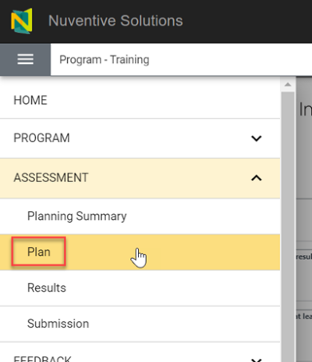
Figure 75: The Plan subtab.
- At the bottom of the relevant Assessment Method, click the Manage Assignment icon (the green circle with a wrench inside) to the right of Assignment (Figure 76). You may need to click the arrow to the left of the PLO and/or the arrow to the left of the Assessment Method to see the Assignment option.
Important: OPAIR Recommends that you do not use the Assignment for the PLO (the assignment option farthest to the left) (Figure 76). This is used to provide findings for the outcome as a whole rather than providing them individually by Assessment Method. The preferred approach is to report findings individually for each Assessment Method.
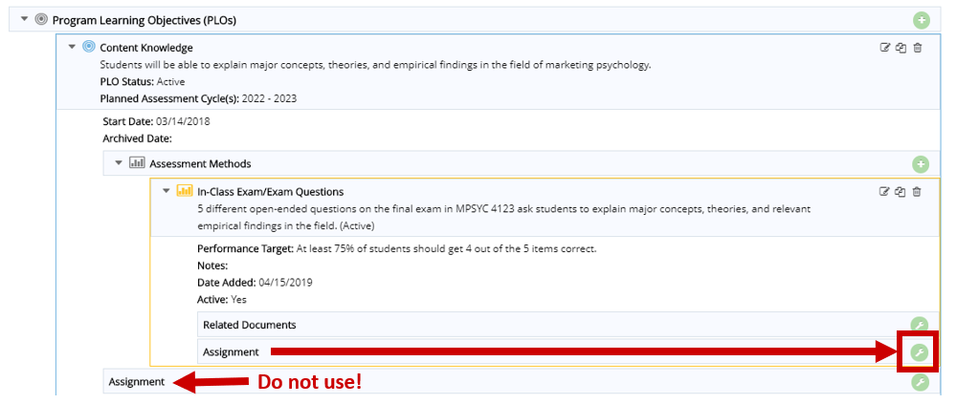
Figure 76: The Manage Assignment icon for an Assessment Method.
- Enter and edit the fields and options displayed in the Plan Assignment screen. An asterisk (*) indicates required fields. The Subject and Notes/Instructions fields auto-populate with information from your Assessment Method (Figure 77). We recommend that you edit the content in those fields to give your Assignee more information about what you’d like them to do.
Important: We recommend that you edit the default Subject and supplement the default text in Notes/Instructions field with instructions that make it very clear what you are asking the Assignee to do. For example, “Please report the findings from your final project as assessed using the Communications rubric designed for program assessment. Please disaggregate findings for residential and World Campus students.”
- We recommend selecting the boxes for E-mail Assignment to Assignee(s) and Send CC to Person Assigning (you) (Figure 77). If you select both options, emails will be sent to the Assignee and to you. This ensures that your Assignee is alerted to the assignment and that you have a record of the assignment that was sent to the Assignee. We also recommend emailing your Assignee to let them know to expect something from you via the AMS. If you do not select the E-mail Assignment to Assignee(s) and your Assignee is an Email-Only user, they will have no way of knowing that they’ve been assigned a task. Even Assessment Leaders may not notice the assignment unless they are actively checking for it when they log in.
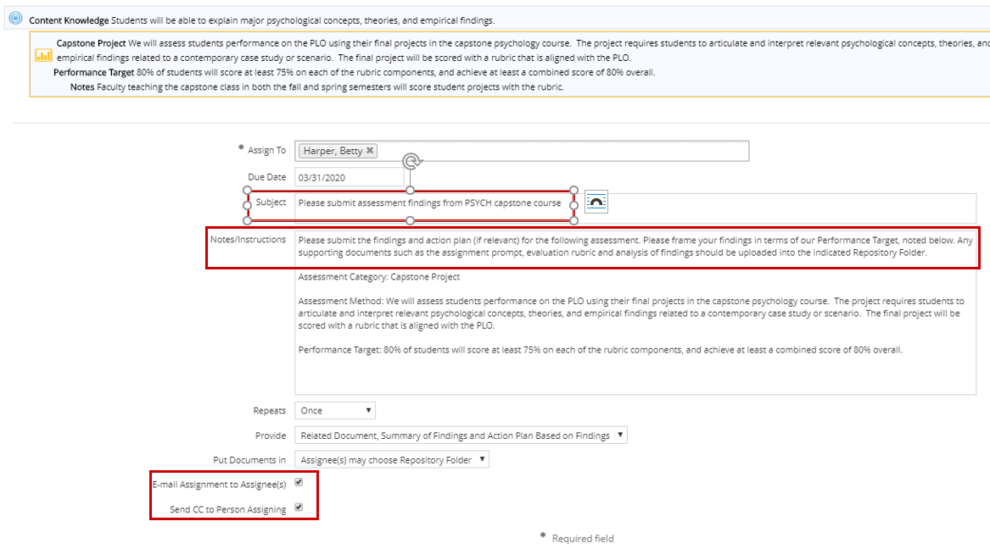
Figure 77: Assignment fields for an Assignment.
- On this screen you can task someone with providing an Action Plan Based on Findings, in addition to providing their Findings (Figure 77).
- Save and Return to return to the Plan page.
- A green message box displays in the upper right-hand corner to confirm your assignment was created and, if selected, the email(s) sent out. The Assignee’s name appears with the entered due date below the Assignment, at the bottom of the Assessment Method (Figure 78).
- Check Spam or Junk folders for the mailbox if you selected to receive an email for the assignment and there is trouble locating the email.
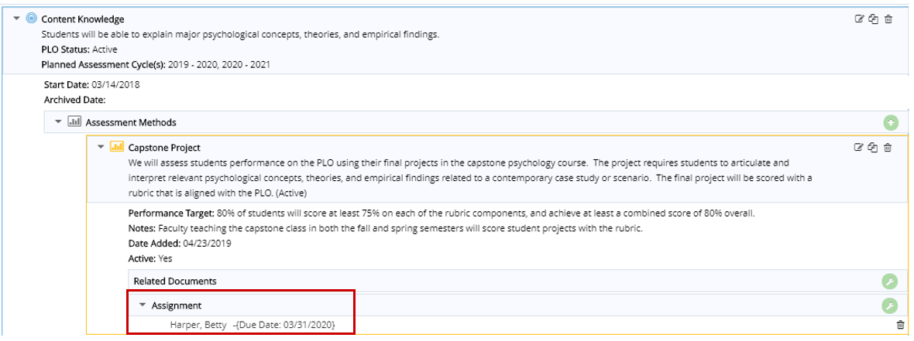
Figure 78: An Assignment for a PLO.

Assign Task: Completing Action Plans
Going to the Results subtab and assigning an Action Plan Based on Findings to another user gives them the responsibility to mark an Action Plan entered by an assessment leader Completed. It is not used to assign another user with the task of entering an Action Plan (see Assign Task: Reporting Findings and Action Plans for details instructions on asking another user to enter an Action Plan).
- Click the Assessment tab from the drop-down menu.
- Click the Results subtab under the Assessment tab (Figure 79).
Figure 79: The Results subtab.
- At the bottom of the relevant Action Plan Based on Findings, click the Manage Assignment icon (the green circle with a wrench inside) to the right of Assignment (Figure 80). You may need to click the arrow to the left of the Action Plan Based on Findings to see the Assignment option.
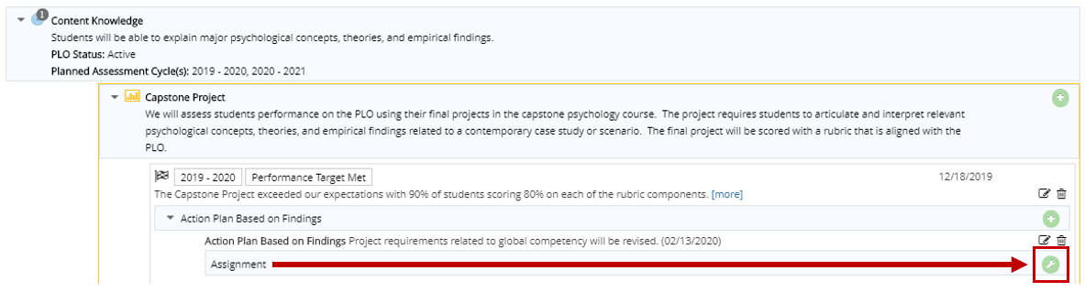
Figure 80. The Manage Assignment icon for an Action Plan.
- Enter and edit the fields and options displayed in the Action Plan Based on Findings Assignment screen. An asterisk (*) indicates required fields. The Subject and Notes/Instructions fields auto-populate with information from your Action Plan Based on Findings (Figure 81). We recommend that you edit the content in those fields to give your Assignee more information about what you’d like them to do (i.e., note when an Action Plan is complete) and that you include a due date.
- We recommend selecting the boxes for E-mail Assignment to Assignee(s) and Send CC to Person Assigning (you) (Figure 81). If you select both options, emails will be sent to the Assignee and to you. This ensures that your Assignee is alerted to the assignment and that you have a record of the assignment that was sent to the Assignee. We also recommend emailing your Assignee to let them know to expect something from you via the AMS. If you do not select the E-mail Assignment to Assignee(s) and your Assignee is an Email-Only user, they will have no way of knowing that they’ve been assigned a task. Even Assessment Leaders may not notice the assignment unless they are actively checking for it when they log in.
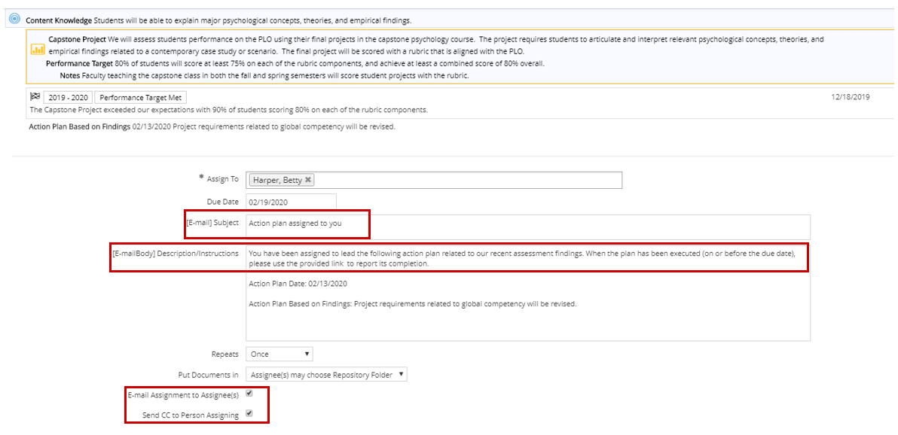
Figure 81. Assignment fields for completing an Action Plan.
- Save and Return to return to the Results screen.
- A green message box displays in the upper right-hand corner to confirm your assignment was created and, if selected, the email(s) sent out. The Assignee’s name appears with the entered due date below the Action Plan Based on Findings Assignment, at the bottom of the Assessment Result (Figure 82).
- Check Spam or Junk folders for the mailbox if you selected to receive an email for the assignment and there is trouble locating the email.
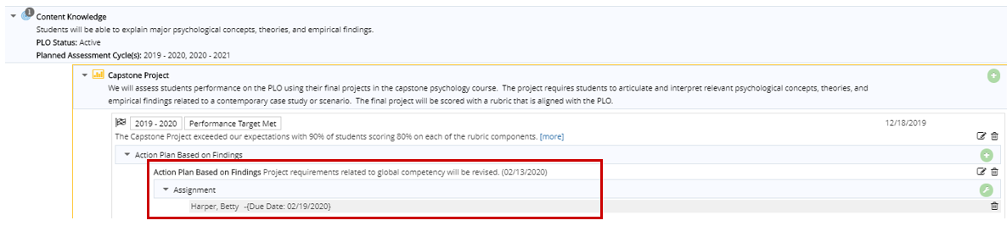
Figure 82. An Assignment for an Action Plan.

Find and Complete Tasks Assigned to You
- Click the My Assignments tab in the menu (Figure 83).
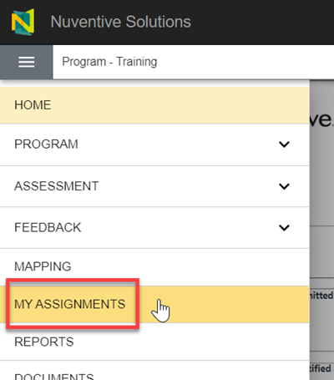
Figure 83: The My Assignments tab.
- The My Assignments page shows any tasks to which you’ve been assigned in the AMS for this Program (Figure 84).
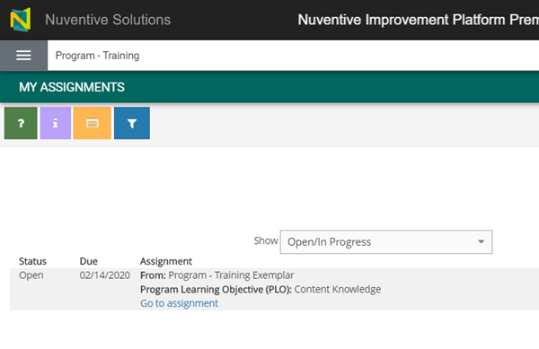
Figure 84: The My Assignments page for a user.
- Click the Go to assignment link for the Assignment you wish to complete.
- Enter information required in the fields for the assignment. In some circumstances you may be asked to attach a document to your assignment or add an Action Plans Based on Findings.
- Click the Save button in the upper right-hand corner of the screen.
- A prompt displays asking if you want to complete your assignment. Click Complete Assignment to complete the assignment. Click Keep Editing if you are still working on your assignment (Figure 85).
Important: Once you’ve clicked the Complete Assignment button, you cannot go back and edit the assignment. Reach out to your Assessment Leader or your Assessment Liaison (opens in new window) to have this information edited.
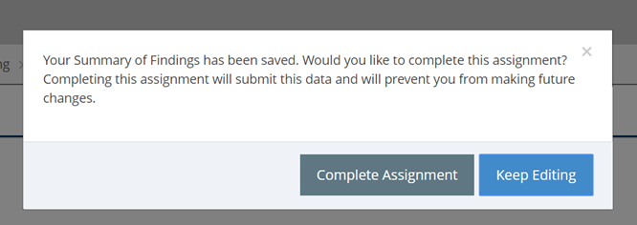
Figure 85: A prompt to complete an Assignment.
- No automated notifications regarding the completion of this task are sent out via the AMS. We recommend emailing your assigner to let them know you completed your assignment.

Curriculum Mapping
A curriculum map shows how a program’s courses align with its PLOs. Curriculum maps can be used to identify opportunities for collecting evidence of student learning and achievement. They can also identify PLOs that are not receiving adequate coverage via the curriculum. At their core, they describe the alignment between the courses and experiences all students must complete in the program’s curriculum and PLOs.
In the AMS, curriculum maps are based on individual active courses from Penn State’s University Bulletin. Courses that are not currently active in the Bulletin cannot be used in the curriculum map.
Where students may select from a selection of courses to meet a requirement, a “Restricted Electives” column(s) can be added to your curriculum map, but the system does not currently allow for these to be defined within the map. Programs can have up to 11 sets of elective groups in the map. If you need more, contact your Assessment Liaison (opens in new window), or the OPAIR office, (814) 863-8721, for assistance.
Important: OPAIR encourages users to define sets of Restricted Electives in a document kept in the AMS Document Repository “General” folder for reference.

Find and Navigate Your Curriculum Map
Click the Mapping tab from the menu panel to view your map (Figure 86). You must have PLOs and assigned courses to have a map. If you do not see a map, contact your Assessment Liaison.
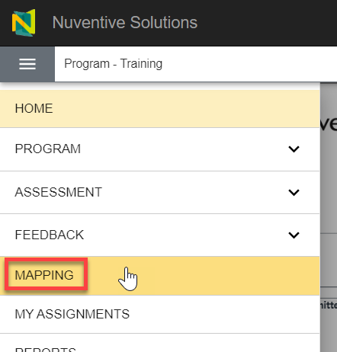
Figure 86. The Mapping tab.
Use the key below to interact with your program’s Curriculum Map in the AMS (Figure 87). By default, courses are listed in alphabetical order, but programs can re-order them to their preference.
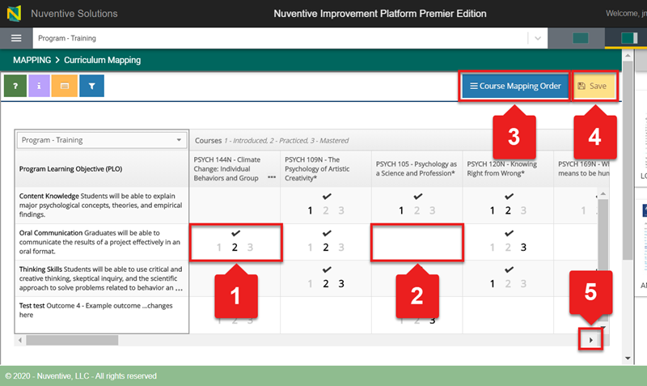
Figure 87: A diagram of the Curriculum Map in the AMS interface.
- Where a course and a PLO intersect, programs should indicate the level of achievement at which faculty expect students to perform in that class with respect to that PLO. Click the cell where the course and PLO intersect and select a number to indicate the level. The number will go from grey to black when selected. Select multiple levels in a single cell, as needed (e.g., a student is both introduced to and practices a PLO in the same course). Clicking on the numbers or boxes will also unselect boxes.
  - Introduced (1) means the students in that course are expected to gain an introduction to the concepts or skills associated with the corresponding PLO.
  - Practiced (2) means the students in that course are expected to gain practical skills relating to the concept’s skills associated with the corresponding PLO.
  - Mastered (3) means the students in that course are expected to demonstrate mastery of the concepts or skills associated with the corresponding PLO.
- Not every PLO has to be addressed in every course.
- You can use the Course Mapping Order button to click-and-drag courses in the sequential order of your choice. See Rearrange Course Mapping Order for more in-depth instructions.
- After editing a Curriculum Map, be sure to Save your changes.
- Click the lower scroll bar to see more courses within your program’s Curriculum Map.

Add and Delete Courses from Your Program’s Curriculum Map
At this time, users cannot add or delete courses from a Curriculum Map. If you need to add or delete a course, please contact your Assessment Liaison (opens in new window), or the OPAIR office, (814) 863-8721, for assistance.

Rearrange Course Mapping Order
Courses are in alphabetical order by default in your curriculum map. When completing a curriculum map, it is best to place courses into the table in the typical order in which students take them. Once you rearrange your course mapping order, there is no reset option to return the order to its default setting. You would have to manually reset the courses to return them to alphabetical order.
- Navigate to your program’s Curriculum Map and click the Course Mapping Order button in the upper right-hand corner (Figure 87).
- Hover your cursor over the hamburger icon (i.e., three horizonal green lines) to the left of the Course ID you want to move until your cursor turns into a four-way arrow (Figure 88).
- Click and drag the course to the order in which you want it. A green message box displays in the upper right-hand corner to confirm successful reordering of your courses.
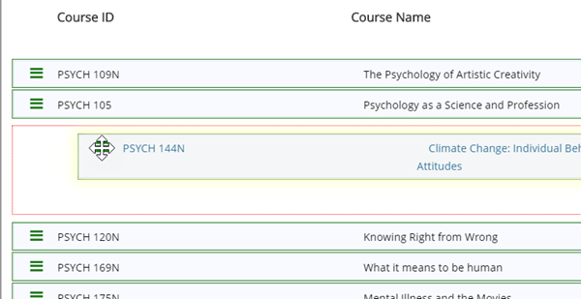
Figure 88. A course being dragged to another position in the curriculum map.
- Click the Return button in the upper right-hand corner when you’re finished rearranging courses to go back to the Curriculum Map. Any changes made to the course mapping order will automatically save.

Generating Reports in the AMS
Assessment Leaders can pull a variety of reports from the AMS.
- Assessment Report: This report shows the PLOs for your selected program, along with any information contained in the Assessment Plan. The report is displayed in a narrative layout with your program’s General Information displayed at the top and may include a list of courses tied to PLOs in your Curriculum Map.
- Assessment Report (4-column): This report shows the PLOs for your selected program, along with any Assessment Methods, Assessment Results, and Action Plan Based on Findings related to those PLOs. The report is displayed in a four-column layout with your program’s General Information displayed at the top of the report.
- Curriculum Mapping: This report shows the PLOs of your selected program and how each selected Course is related to those PLOs using Curriculum Mapping.

Create and View a Report
- Click the Reports tab from the drop-down menu (Figure 89).
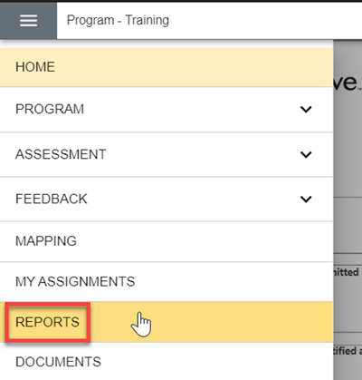
Figure 89. The Reports tab.
- Click the link for the report type that you want on the Reports page.
- Report format options include PDF, HTML, and Word.
- Your report must be given a title.
- The drop-down menus in the Filter section and/or the checkboxes in the Options section can be used to customize your report (see Filtering Reports in the AMS for additional details).
- The Filters and Options sections allow you to show one or multiple Assessment Cycles, and Active or Archived PLOs, among other options. When you click on the link to a Report on the Reports page it takes you to a form. This form allows you to enter information and choose your filters and options for that report.
- (Optional) In the Filter section, click the PLO Status field and select Active. This removes Archived PLOs from your generated report (Figure 90).
Important: The best way to get the most from your reports is through using the Filters and Options sections when you create a report.
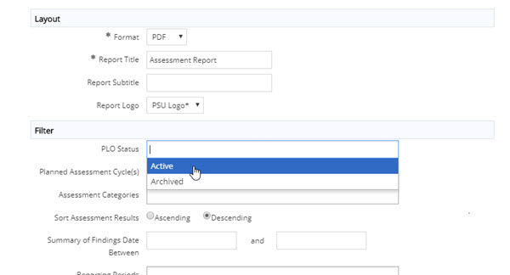
Figure 90. The PLO Status field.

- Click the yellow Open Report button in the upper right corner to view it. If you do not see your Report, you may need to allow pop-ups for this site and repeat this process. See this website for instructions to turn off pop-up blockers if you’re not sure.

Save a Report
You have two options to save a report in the AMS; you can save it as a zip file, or you can save it to the Document Repository in the AMS.

Save a Report as a Zip File
Important: All report formats include hyperlinks to related documents, but only other Assessment Leaders with AMS access will be able to open the hyperlinks generated in the reports. If you want to share these reports with non-users, then OPAIR recommends that you use the Open Report >Download as Zip option (Figure 90). The zip folder includes the report and any documents related to the Program’s Assessment Methods or Assessment Results.
- Click the link for the report you want on the Reports page.
- Modify any information in the Layout, Filter, or Options sections to customize your report.
- Click the down arrow to the right of the Open Report button and click Download as Zip from the drop-down menu (Figure 91).
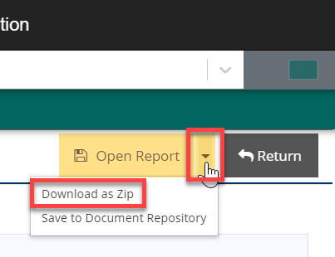
Figure 91. The Download as Zip option.
- Click the Return button in the upper right-hand corner to return to the Reports page.
Your report is saved as a zip file that includes any documents you related to your Program’s Assessment Methods or Assessment Results. Find the zip file in your Downloads folder on your computer.

Save a Report to the Document Repository
- Click the link for the report you want on the Reports page.
- Modify any information in the Layout, Filter, or Options sections to customize your report.
- Click the down arrow to the right of the Open Report button and select Save to Document Repository from the drop-down menu (Figure 92).
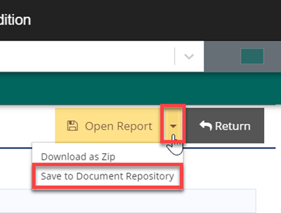
Figure 92. The Save to Document Repository option.
- Select a folder and (optionally) edit the report name and description and Save (Figure 93).
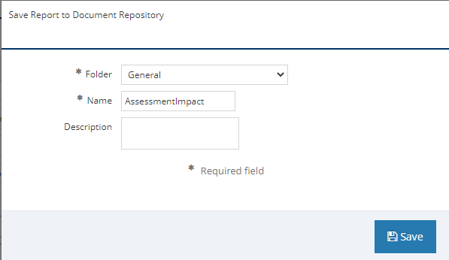
Figure 93. Assign report to folder and give it a name and description.
- Click the Return button in the upper right-hand corner to return to the Reports page. Your report is saved to the Document Repository in the AMS.

Report Feedback
Once you submit your program results for an Assessment Cycle, OPAIR staff review your submission and provide feedback on it. The purpose of this feedback is to guide you regarding your submission and recommend any opportunities to strengthen your assessment approach. Feedback can be found as described below.

Find Your Feedback
- Click the Feedback tab from the drop-down menu (Figure 94).
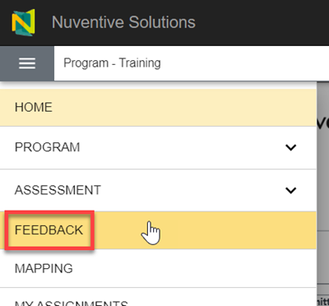
Figure 94: The Feedback tab.

- Any feedback for the selected program displays in Assessment Cycles (i.e., academic years) (Figure 95). If you need help interpreting your feedback, contact your Assessment Liaison.
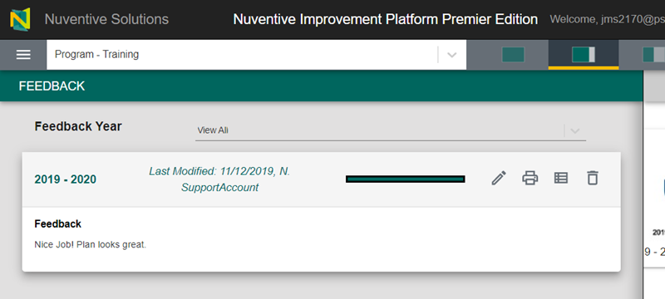
Figure 95: Feedback in the Feedback page.

AMS Resources
For resources and information about the assessment process at Penn State, please visit the OPAIR Website (opens in new window).
All colleges and campuses are assigned an Assessment Liaison to support your assessment process. If you need help with the AMS interface or anything assessment related, reach out to your Liaison and they will be happy to assist you. Visit the Assessment Liaison webpage (opens in new window) to find out who your liaison is. If you need immediate assistance, please call OPAIR at (814) 863-8721.

Appendix: Guide for Email-Only Users

The Email-Only Role
If you are an Email-Only user, you cannot access the full range of functions in the AMS. As an Email-Only user, you can complete tasks emailed to you by an Assessment Leader using the AMS. This may require entering assessment results, entering assessment plans based on the results, marking action plans complete, or relating (uploading/attaching) a document. Links within the emails allow you to complete these tasks and apply them to the relevant program in the AMS. You won’t see the same interface that Assessment Leaders see. As an Email-Only user, you will only see options directly relevant to your assigned task.
This appendix is intended to show you how to complete tasks and interact with the Email-Only user interface. If you need help, please contact your Assessment Liaison (opens in new window).
Throughout this index, particularly critical information will be highlighted with the word “Important”. What follows are important information and best practices that help make this process as easy as possible.
Note: As an Email-Only user, you must first be added to the AMS by OPAIR staff before Assessment Leaders can assign you tasks. If you cannot access the AMS links in your email, reach out to your Assessment Leader. They must contact their Assessment Liaison (opens in new window) and add you as an Email-Only user. They must provide your:
- Name
- Program name and level (e.g., A.S., B.A., B.S., M.S., PhD., undergraduate/graduate certificate)
- Campus

Assignments/Tasks in the AMS
When an Assessment Leader has assigned you a task you will receive an email.
Important: If you are expecting an email and don’t see it in your Inbox, check your Spam and Junk folders.
This email includes relevant program information, such as a Program Learning Objective (PLO), an Assessment Method, and a Performance Target (if entered). It also includes a due date for completion (if applicable), and the name of the Assessment Leader who created this task for you. If the Assessment Leader added additional information relevant to your task, you will see it in this email, under Notes/Instructions.
As an Email-Only user, you may be asked to:
- Enter Assessment Results (i.e., Summary of Findings) and Action Plans Based on Findings for a PLO
- Relate (upload/attach) supporting documents
- Mark Action Plan(s) completed

Access Your Assignment
- Click the link in the email to access your assignments page in the AMS. The assignment related to the email in which you clicked the link is highlighted on the webpage. You will see the assignment’s status, due date, and information along with a link to the assignment.
- Click the Go to assignment link at the bottom of the highlighted assignment (Figure 96). A new browser window opens in the AMS and displays your assignment.
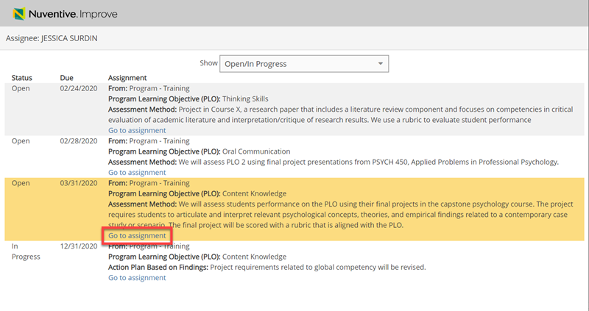
Figure 96. The Go to assignment link in the assignments page.

Assignment: Submit Assessment Results and an Action Plan
Some assignments may require you to enter both Assessment Results and an Action Plan Based on Findings for your program’s PLO and associated Assessment Method. While some assignments may require you to only enter Assessment Results for your program’s PLO and associated Assessment Method. The steps below show you how to complete these types of assignments and relate (upload/attach) a document, if needed.
- Navigate to your assignment.
- Enter Assessment Results information in the fields displayed on this page. An asterisk (*) indicates a required field. Relevant information about field requirements displays when you click the blue help circle with a question mark next to the field.
- If you were not asked to enter an Action Plan Based on Findings, skip to step 7. If you were asked to enter an Action Plan Based on Findings, next click the Add Action Plan Based on Findings icon (green circle with a plus) to the right side of the Action Plan Based on Findings bar at the bottom of the window (Figure 97).
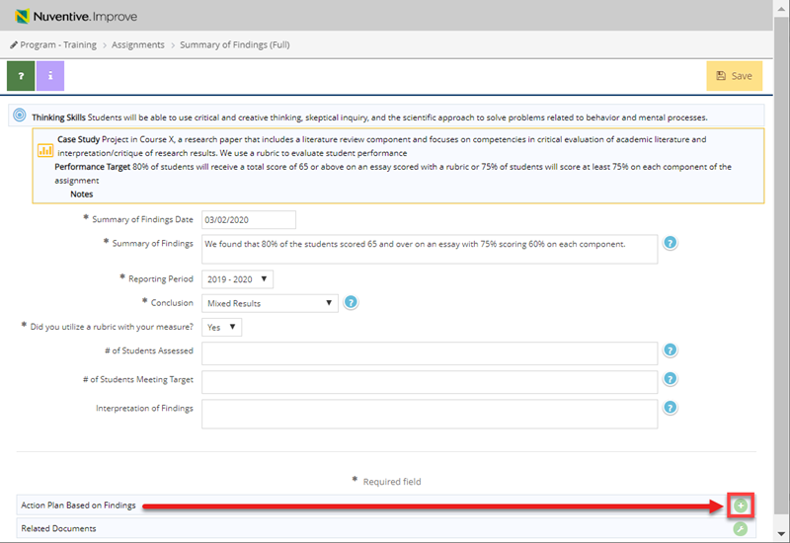
Figure 97. The Add Action Plan Based on Findings icon.
- Enter the Action Plan Based on Findings information in the fields on this page. An asterisk (*) indicates a required field. Relevant information about field requirements displays when you click the blue help circle with a question mark next to the field.
- To save your work, there are multiple options:

  - Click the Save button to save your Action Plan Based on Findings and remain on that page to make edits (Figure 98).
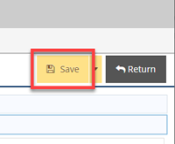
Figure 98. The Save button.
  - Click the arrow to the right of the Save button and select Save and Return to save your Action Plan Based on Findings and return to the Summary of Findings page (Figure 99).
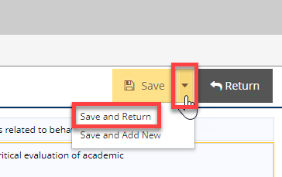
Figure 99. The Save and Return option.
  - Click the arrow to the right of the Save button and select Save and Add New to save your Action Plan Based on Findings and add another (Figure 100).
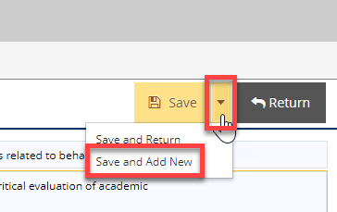
Figure 100. The Save and Add New option.
- If you did not choose the second option (Save and Return) and have finished adding your Action Plan Based on Findings, click the Return button to return to the Summary of Findings page. Your Action Plan information displays below the Action Plan Based on Findings bar. Use the icons to the right of the Action Plan to edit (pen/paper icon) or delete (trash can icon) your Action Plan Based on Findings (Figure 101).
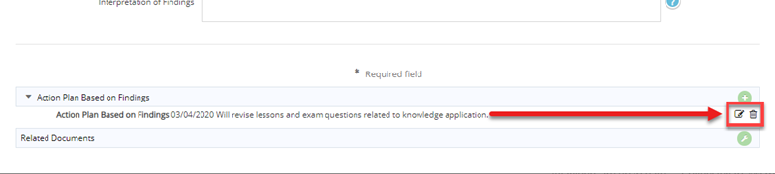
Figure 101. The Edit and Delete icons for Action Plans Based on Findings.
- (Optional) Relate (upload/attach) any documents requested by your Assessment Leader for your Assessment Results or Action Plan Based on Findings (Assignment: Relate (Upload/Attach) a Document).
- Review your entries for accuracy and completion.
- Click the Save button in the upper right-hand corner. A prompt opens asking you to confirm that your assignment is completed.
- (Optional) Click the Keep Editing button to complete any additional tasks, such as Relate Documents.
- If you have completed all tasks within your assignment, click the Complete Assignment button in the prompt. A green box in the upper right-hand corner indicates you submitted your assignment.
Important: At this point all revisions are final for your assignment. You cannot return to make changes once you click the Complete Assignment button.
Important: It is a best practice to send an email to your assigner to communicate completion. No notification emails are sent from the AMS alerting your assigner that your assignment is complete.

Assignment: Relate (Upload/Attach) a Document
Some assignments may require you to attach a document. You must first upload the document to the Document Repository before attaching it. The steps below show you how to complete this type of assignment by relating (uploading) and then attaching a document.
- Navigate to your assignment. Your screen displays the PLO, Assessment Method, and a Related Documents bar for your assignment.
- Click the Relate Documents icon (green circle with a wrench) on the right side of the Related Documents bar (Figure 102).
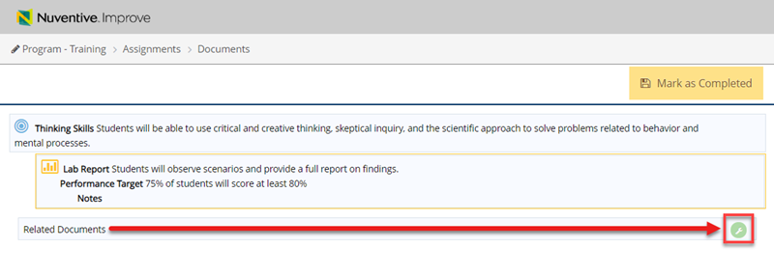
Figure 102. The Related Documents icon.
- Click the Upload new documents icon (green circle with a plus) in the right corner of the Document Repository (Figure 103). A new window opens.
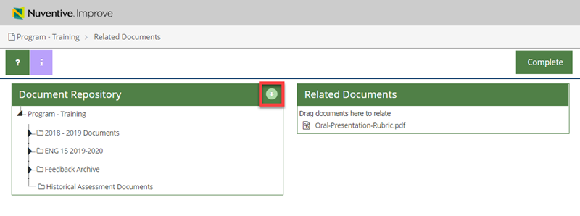
Figure 103. The Upload new documents icon.
- Click the Places documents into field. A drop-down menu opens.
- Select a folder from the drop-down menu to which you want to upload the document.
- Click the Files field to browse files on your computer (Figure 104).
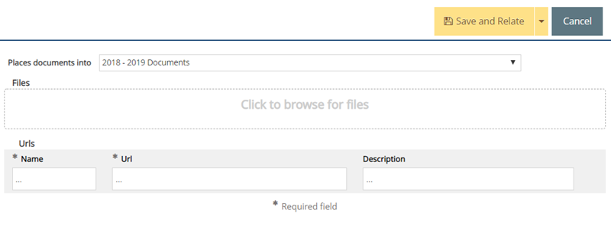
Figure 104. The Files field.
- Select the file or item you wish to attach to the assignment and click the Open button. Your file displays below the Files field.
- (Optional) Add a description for the document in the Description field for the file.
- (Optional) Repeat Steps 1-8 to add another document.
- Click the Save and Relate button in the upper right-hand corner of the window (Figure 105).
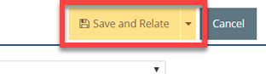
Figure 105. The Save and Relate button.
- Your chosen document displays under the Related Documents section, and in the folder that you selected in Step 5. A green box in the upper right-hand corner indicates your document was added to the Related Documents section.
- (Optional) Click the downward triangle in a box icon to the right of the document and click Un-relate Document to remove the document from the Related Documents section (Figure 106).
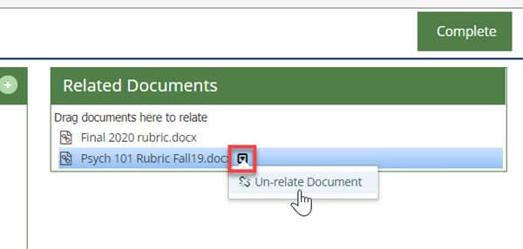
Figure 106. The downward triangle and Un-relate Document option.
- Click the Complete button in the upper right-hand corner of the window.
- Review the information and make any necessary changes.
- (Optional) Click the Un-relate Document icon (broken chain link) to the right of the document to remove the document from the assignment (Figure 107).
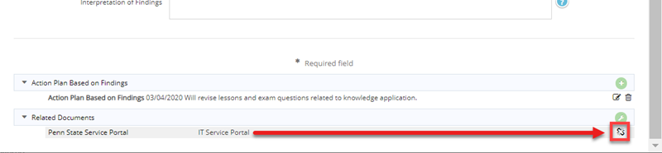
Figure 107. The Un-relate Document icon.
- Click the Mark as Completed button in the upper right-hand corner of the window. A green box in the upper right-hand corner indicates that your assignment is now complete.
Important: Once you click the Mark as Completed button, you cannot return to the assignment to make changes.
Important: It is a best practice to send an email to your assigner to communicate completion. No notification emails are sent from the AMS alerting your assigner that your assignment is complete.

Assignment: Action Plan Based on Findings
- Navigate to your assignment. Your screen displays the PLO, Assessment Method, Action Plan Based on Findings, and a Related Documents bar for your assignment.
- Mark the Action Plan Based on Findings complete by clicking on the yellow box on the top right (Figure 108).

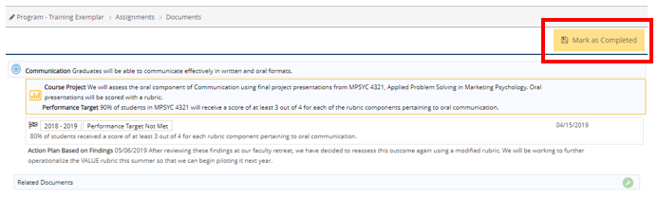
Figure 108. Marking an Action Plan complete.

Complete an Assignment with Multiple Tasks
Assessment Leaders may assign you more than one task per assignment. For example, an Assessment Leader may require both Assessment Results and an Action Plan Based on Findings be completed together within one assignment. Another example may be completing an Assessment Result and attaching a rubric.
Important: If you are assigned multiple tasks, do not click the Mark as Complete/Complete Assignment buttons until all tasks are completed. You cannot go back and edit your entries/submission after you’ve clicked either button.

