Effective Communication Assessment
  - 2021-2022

Executive Summary
Penn State assessed the Effective Communication, one of seven learning objectives for the General Education curriculum, in 2021-22 using a rubric developed and applied by faculty. During the fall and spring 1,527 unique instructors across the Commonwealth taught 4,950 course sections designated as meeting the Effective Communication objectives; 14% of invited instructors contributed to the study with data from 5% of all course sections. Instructors reported the number of students considered to be developing, satisfactory, and exemplary for each of the three Effective Communication criteria: substance, delivery, and adaptation to audience and community building. Overall, students scored similarly across all three criteria. While we might expect students to develop increasing communication proficiency over the course of their academic careers, the data reveal relatively consistent results across course levels. Responses were also grouped by General Education domains (e.g., quantification, arts) to look for overall patterns but there were no significant difference by domain. Several limitations have been identified in the 2021-22 study that have informed the approach to the 2022-23 study of the Creative Thinking and Global Learning outcomes. The Joint Committee on General Education Assessment will use this year to explore questions around the acceptable ratio of developing/
satisfactory/exemplary scores and whether all General Education courses, regardless of course level, should be expected to achieve the same level of student performance on the appropriate learning outcomes.

Introduction
Direct assessment of learning objectives is a key component of Penn State’s approach to General Education. In 2021-2022, Office of Planning, Assessment, and Institutional Research (OPAIR) staff, with guidance from the Joint Committee on General Education Assessment and the General Education Scholars, assessed the Effective Communication objective.
Effective Communication is the ability to exchange information and ideas in oral, written, and visual form in ways that allow for informed and persuasive discourse that builds trust and respect among those engaged in that exchange, and helps create environments where creative ideas and problem-solving flourish.

Methods
Penn State’s 2019-2020 General Education Faculty Scholars worked closely with OPAIR staff to develop an Effective Communication rubric that would be relevant across disciplines. The rubric (see Appendix) focused on three criteria:
- Substance – Does the communication address the topic or subject matter it is supposed to address and is it relevant and compelling in doing so?
- Delivery – Formal qualities or elements of the mode of communication including grammar, mechanics, technique involved in presentation, and techniques or conventions relevant to the format.
- Adaptation to Audience & Community Building – Is the communication successful at inviting an audience to engage with the communication and the degree to which it builds trust or respect between communicator and receiver?
Instructors were asked to choose an assignment that required students to engage in an act of communication. Communication was not restricted solely to written and oral forms but could include a diverse range of modalities where students were asked to communicate thoughts, ideas, emotions, feeling, and more. Communicative acts in these varied contexts could include, but were not limited to, multimedia forms, artworks, designs, musical performances, and body movement or expressions.
When choosing from available assignments, participants were encouraged to select those assignments that were more valuable in a student’s overall grade (i.e., at least 10%) because these are typically better in an assessment context as students take them more seriously. This leads to a more authentic demonstration of their skills. Final projects, presentations, papers, and pieces were provided as examples of the best types of assignments for assessment. Participants were strongly encouraged to use an existing assignment rather than creating a new one solely for the purpose of the assessment study.
Instructor participants evaluated individual student assignments on a three-point scale—developing (1), satisfactory (2), or exemplary (3)—for each criterion on the rubric. Assessment best practice would have all study instructors participate in a group training and norming session to develop a shared understanding of the rubric and how to apply it. This norming process would allow for the establishment and documentation of interrater reliability. In other words, it would help minimize variation in how different instructors interpret and apply the rubric. When the current assessment approach was first tested with the Integrative Learning objective in 2019, training was offered but invitees did not participate. Hence, the need to minimize the time and effort required to participate was prioritized in 2021-2022 and training was not offered. Individual students’ scores were entered into a provided Excel spreadsheet and tallied into aggregate scores for each performance level and criterion. This aggregate data was then submitted by instructors via an online form.

Instructor Participation
OPAIR staff used institutional data to develop lists of instructors slated to teach at least one General Education course aligned with Effective Communication in fall 2021 or spring 2022. OPAIR staff provided the instructor lists to the relevant academic administrators to alert them that the study was being conducted and that anyone teaching a General Education course is expected to address the objectives selected when the course was re-certified. The assistant vice provost for assessment emailed the relevant instructors prior to the start of both semesters about their role in the upcoming assessment. During the third week of each semester, a second email was sent to instructors with detailed instructions for participating in the study. A final reminder with instructions was sent at the end of both semesters. Spring instructors that participated in the fall assessment were not asked to participate a second time.
In total, 4,950 course sections aligned with the Effective Communication learning objective were conducted during the study period. This number includes sections offered at every Penn State location (21) offering undergraduate courses and via the World Campus. Where courses include separate components (e.g., lab and recitation sections), both are counted. Assessments were submitted for 228 sections (5%). The 4,950 sections were taught by 1,527 unique instructors, of which 217 submitted responses (14%).

Findings
Instructors provided a course code and reported the number of students considered to be developing, satisfactory, and exemplary for each of the three Effective Communication criteria. Overall, students scored similarly across all three criteria (Figure 1).
Figure 1. Overall proficiency across the three criteria among all students scored.

We might expect students to develop increasing communication proficiency over the course of their academic careers. By grouping responses at the course level, we expect to see the numbers of students rated ‘exemplary’ increase with the course level. However, the data show relatively consistent results across course levels. For example, if we look at 3 courses commonly associated with Communication skills, among the values reported for ENGL 15/ENGL 30 students, 43% scored as “exemplary” on criteria 1, as did 44% of CAS 100 students and 42% of ENGL 202 students. Chi-square analysis across levels also suggests that no significant differences in proficiency exist between course levels. This holds true across all three criteria.
One limitation in exploring increasing ability over time - from matriculation to graduation - is the lack of upper-level courses in the study and in the population. Most of Penn State’s General Education courses are lower-level by design and in this study only 1.8% of the course population was 300- or 400-level sections. Subsequently, most reported scores are from 10-, 100-, and 200-level courses. Upper-level courses were represented by scores from only four sections. The small sample size is insufficient for broad analysis across all five levels (010, 100, 200, 300, and 400). Focusing on lower-level courses (10, 100, and 200), there is a pattern of increasing proficiency from levels 10 to 100 and then decreasing proficiency from levels 100 to 200 across all three criteria (Figure 2, Figure 3, and Figure 4). Each criteria had a large effect size (Cohen’s w: 0.85, 0.60, and 0.60), suggesting that the trend may be of practical interest. However, no statistical significance was detected in any of the three criteria and the pattern may be due to random chance in this sample. Future assessments should be conducted to determine the consistency of this pattern. The variation may reflect a lack of shared understanding of the rubric rather than true differences in student performance across the levels or variations in the expectation of an instructor based on the course level. For example, what is considered exemplary for a 10- level course may not be exemplary for a 200-level course. Future assessments should be conducted to determine the consistency of this pattern.
Figure 2. Proficiency based on course level for substance criterion.
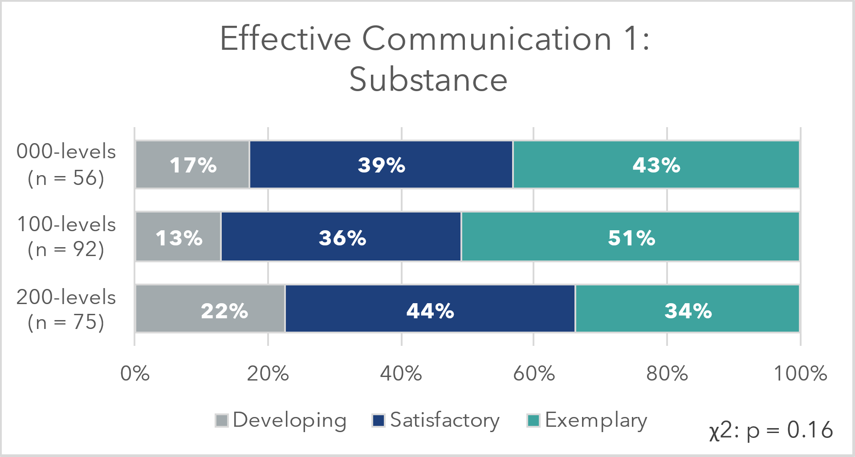
Figure 3. Proficiency based on course level for delivery criterion.
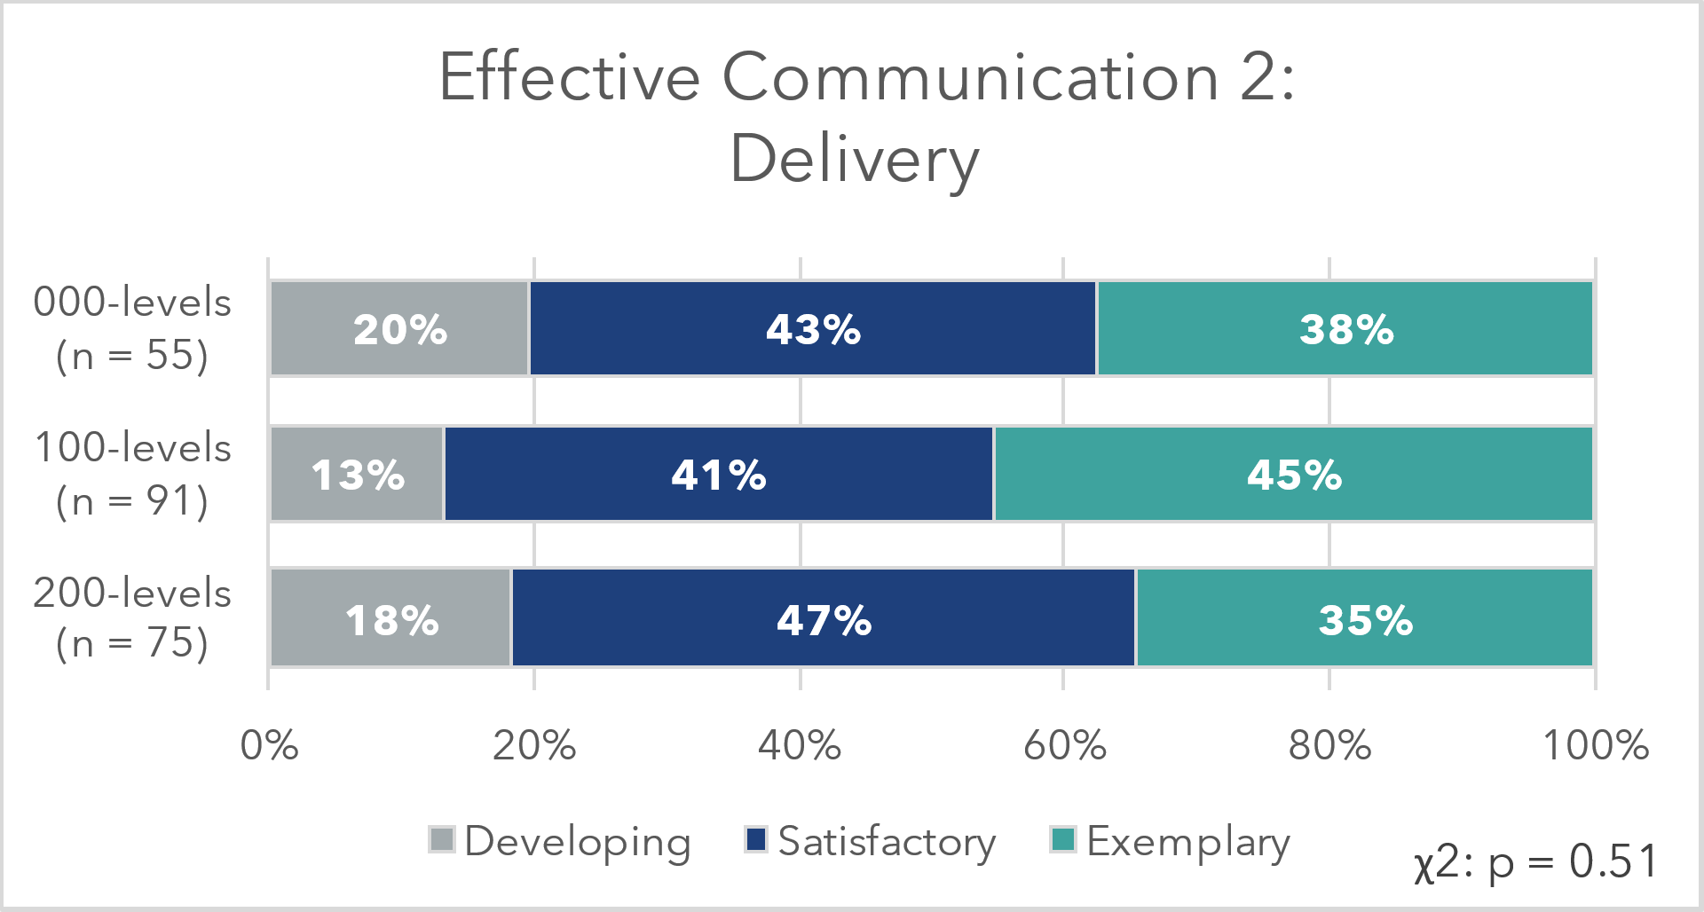
Figure 4. Proficiency based on course level for adaptation to audience criterion.
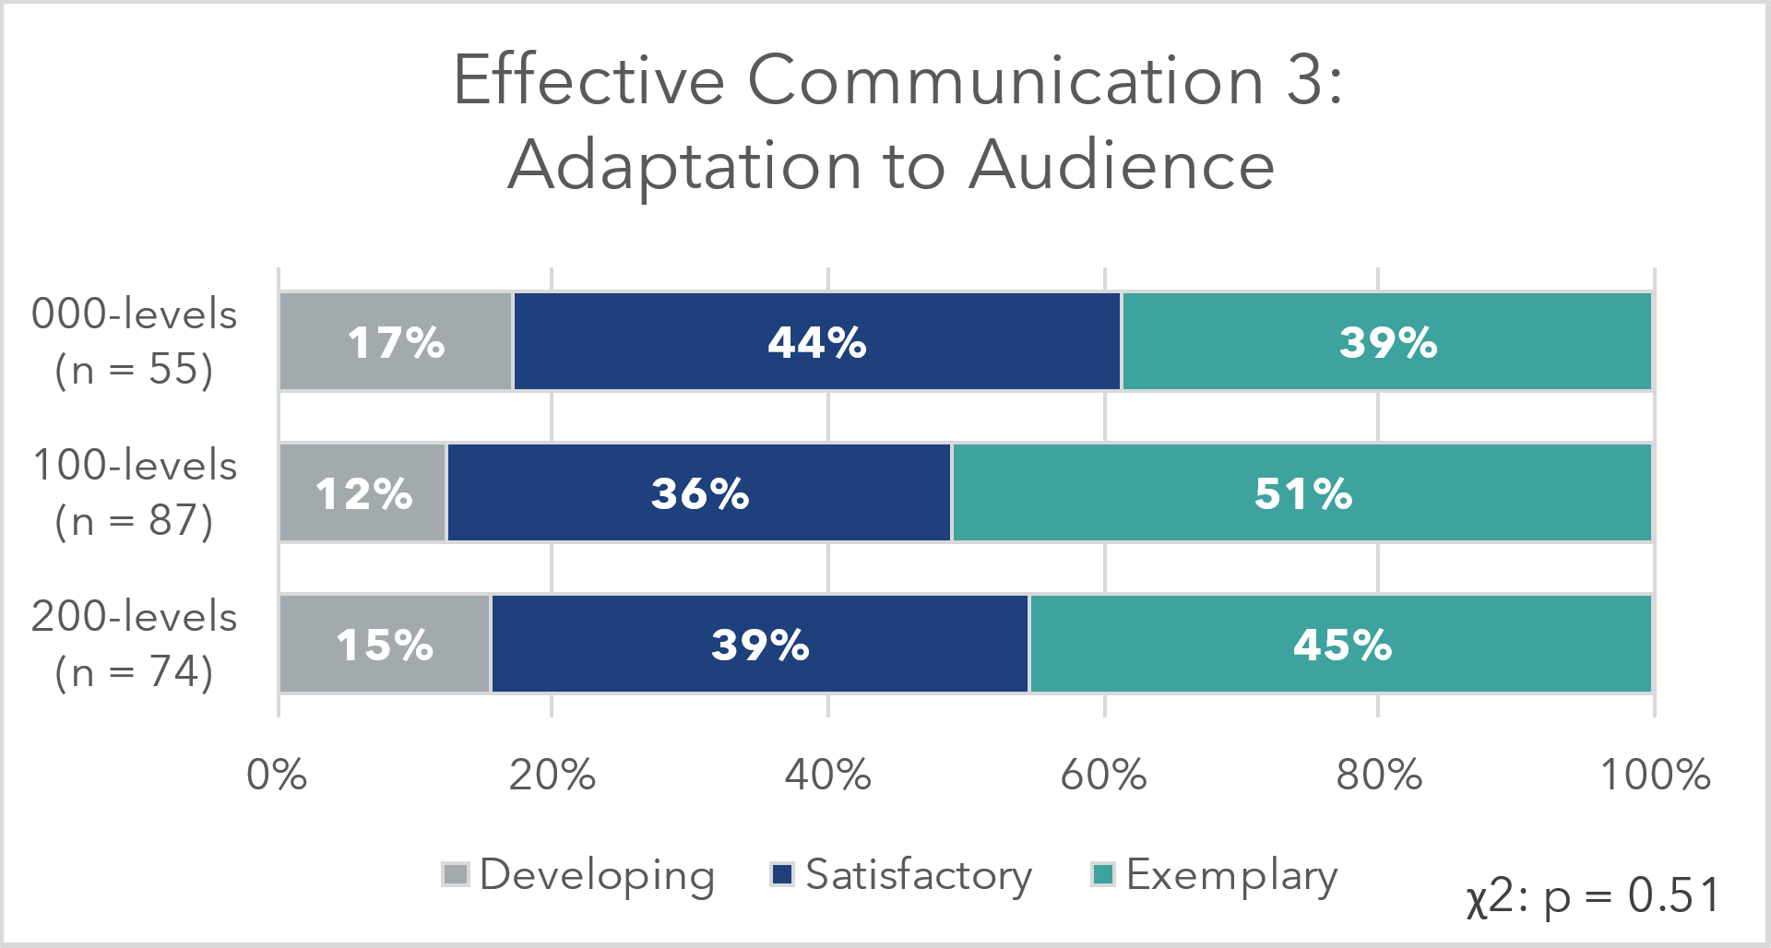

Responses were grouped by general education domains (Table 1) to look for overall patterns.
Table 1. General Education domains.
Code | General Education Domain
GWS | Writing and Speaking
GQ | Quantification
GA | Arts
GH | Humanities
GHW | Health and Wellness
GN | Natural Sciences
GS | Social and Behavioral Sciences

Well-represented domains (e.g., Writing and Speaking) tend to show consistent scoring across all three criteria. Domains with scores from fewer than five course sections d were excluded. The small samples size showed greater variation in the proportion of students at each proficiency level (Figure 5, Figure 6, and Figure 7). Chi-square analysis across levels suggests that no statistically significant differences in proficiency exists between domains, however the large effect size within each criterion (Cohen’s w: 0.83, 0.79, and 0.64) suggests that this is worth monitoring in the future. This holds true across all three criteria suggesting that instructors assess based on the content and structure of their courses and students are meeting the criteria at the same proportion regardless of the domain area in which they receive instruction.
Figure 5. Proficiency based on domain for substance.
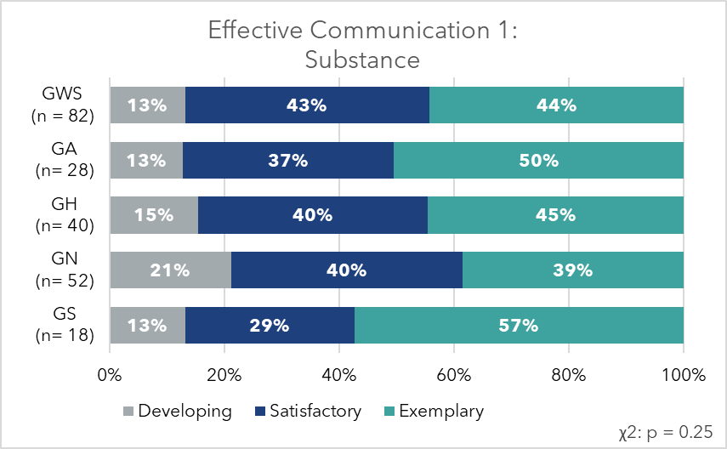
Figure 6. Proficiency based on domain for delivery.
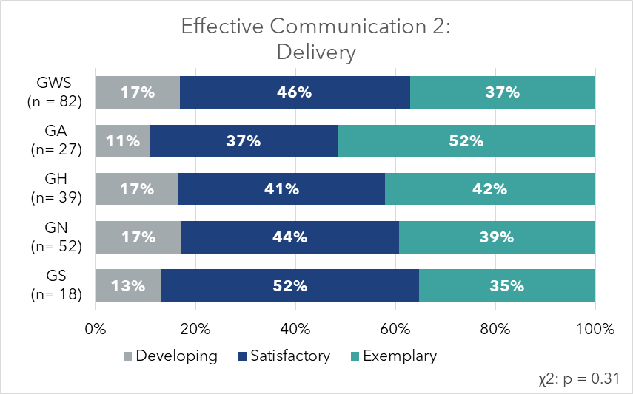
Figure 7. Proficiency based on domain for adaptation to audience.
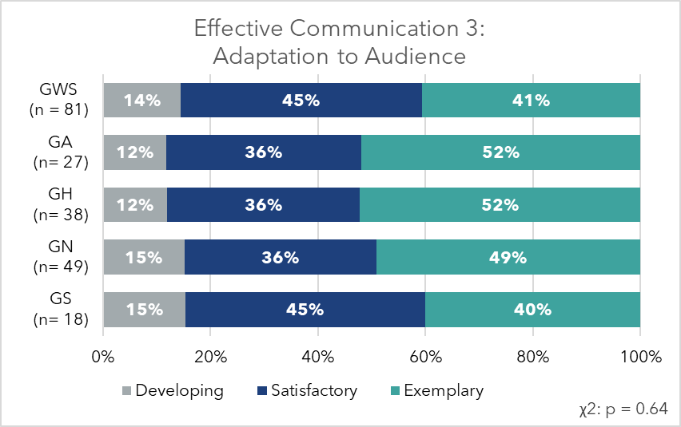

Limitations
Because we prioritized minimizing instructor effort, we cannot establish interrater reliability for the submitted scores or speak to how instructors interpreted the rubric. While this is a weakness in the assessment approach, we consider it an acceptable limitation for the following reasons.
- The rubrics were carefully crafted with specific descriptions of each criterion and performance level.
- The large sample size mitigates the impact of individual instructor variability.
- This approach is fundamental to our ability to collect this data.

Next Steps
General Education learning outcome assessment is a work in progress with the goal of providing actionable data to the General Education community. With each iteration of assessment, we learn and adapt our methods. The general education learning outcome assessment process was first developed in 2019 with Integrative Thinking. In addition to asking instructors to submit their aggregate rubric scores, instructors were asked questions about their course preparation, the aspects of integrative thinking addressed in their courses, and the assignment used for the study. Based on participant feedback, the questionnaire was pared back significantly in 2020-21 for use on Effective Learning. In order to minimize the effort needed to participate in the study, instructors were only asked to submit their aggregate scores. While more efficient for participants, this approach failed to provide important context for the findings reported.
To further advance our understanding of General Education outcomes, the Joint Committee on General Education Assessment has established several questions to guide their learning outcomes work in 2022-2023.
- Should all general education courses, regardless of course level, be expected to achieve the same level of student performance on the appropriate learning outcomes?
- What is an acceptable performance target (or targets if we identify differential standards based on course level)? In other words, what is an acceptable ratio of developing/satisfactory/
exemplary scores?
- How might these choices impact our assessment efforts? How might they impact our support for General Education instruction?
The Global Learning and Creative Thinking general education learning outcomes have been identified for assessment in 2022-23 using the same approach described here. Based on our experience assessing Integrative Thinking and Effective Communication, however, the data collection instruments have been modified to include fundamental information about the assignments scored and to collect information about the performance levels expected by instructors in the selected courses. We anticipate that this change will have minimal impact on the amount of time it takes instructors to participate in the study, while providing important context for the reported scores and more actionable data moving forward.

Appendix
Effective Communication Rubric

Criterion | Developing | Satisfactory | Exemplary
EC1  SUBSTANCE  Substance/content of communication | - Substance/content of the message is somewhat relevant and compelling  - Subject matter is superficially or inadequately addressed | - Substance/content of the message is mostly relevant and compelling  - Subject matter is adequately addressed | - Substance/content of the message is relevant and compelling  - Subject matter is comprehensively addressed
EC2  DELIVERY  Formal qualities/elements of communication (e.g., grammar/mechanics, technique, format) and their capacity to persuade | - Meaning is communicated with clarity and fluency across some of the work  - Communication may include some errors  - Communication is somewhat persuasive | - Meaning is communicated with clarity and fluency across most of the work  - Communication has few errors  - Communication is mostly persuasive | - Meaning is communicated with clarity and fluency throughout the work  - Communication is virtually error-free  - Communication is very persuasive
EC3  ADAPTATION TO AUDIENCE AND COMMUNITY BUILDING Development and respectful transmission of community norms and goals | - Sometimes uses appropriate tone, language, etc... when communicating with others  - Is sometimes attentive, asks questions, provides constructive criticism when appropriate, etc... when others are communicating | - Mostly uses appropriate tone, language, etc... when communicating with others  - Is mostly attentive, asks questions, provides constructive criticism when appropriate, etc... when others are communicating | - Consistently uses appropriate tone, language, etc... when communicating with others  - Is consistently attentive, asks questions, provides constructive criticism when appropriate, etc... when others are communicating
EFFECTIVE COMMUNICATION – the ability to exchange information and ideas in oral, written, and visual form in ways that allow for informed (content) and persuasive (organization, technique, format) discourse that builds trust (audience and situationally appropriate) and respect among those engaged in that exchange, and helps create environments where creative ideas and problem-solving flourish.

